**Lab 1 Assignment: Using REST (Node.js) and React JS**

**Git Repository Link:** [**https://github.com/Hariae/CMPE273-SP19-63**](https://github.com/Hariae/CMPE273-SP19-63)

**Part -1: Simple Calculator Application using Node.js and React.js**

**Purpose:**

To have proper understanding of RESTful Services and interaction between client and server using node.js as a backend server and react.js as frontend client.

**Goal:**

create a simple calculator application with the use of Node.js server and React.js as a client user interface.

The system should perform basic functionalities as below.

1. design a simple look alike online calculator using react.js

2. User can input the values in calculator display by clicking buttons.

3. As per the input the expression will be generated and on click of result button, user must be able to see the calculated result on screen.

4. user must be able to perform following functions using calculator.

1. Addition 2. Subtraction 3. Multiplication 4. Division.

5. Client will make a request to node.js server where server will compute the result and respond to client with result. Client will display the result on screen to user.

**Proposed System Design:**

Computing-server

1. user input operation 2. Output from server.

**System Components:**

**1. Node.js Backend server using express.js :**

Created a backend server which will serve client request and output the result back to client.

This contains a one RESTful service as computation API.

It runs on port 3005 and serves the client which is running on the port 3001 on localhost

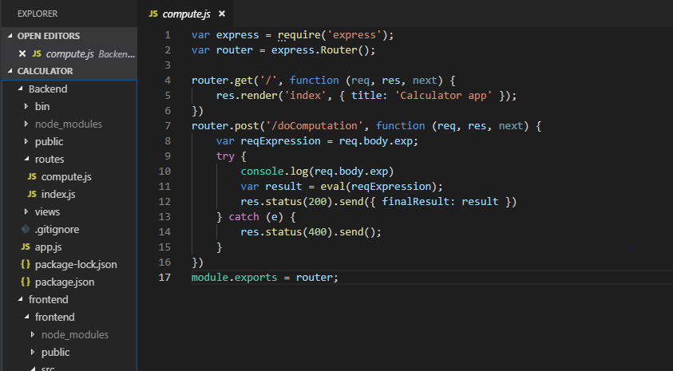

**2. A calculator user interface using React.js:**

A simple user interface for client that should be able to take input from client and display output to client.

Client API makes a call to server for computing the result. Server computes the result and send back a JSON response to client where client displays this result on the screen.

The frontend structure is described as below.

**1. Calculator.js (display calculator)**

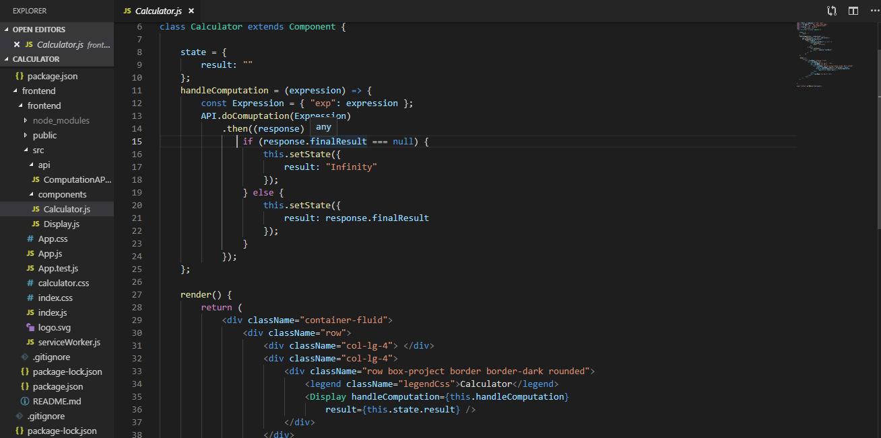

**2. Computation API.**

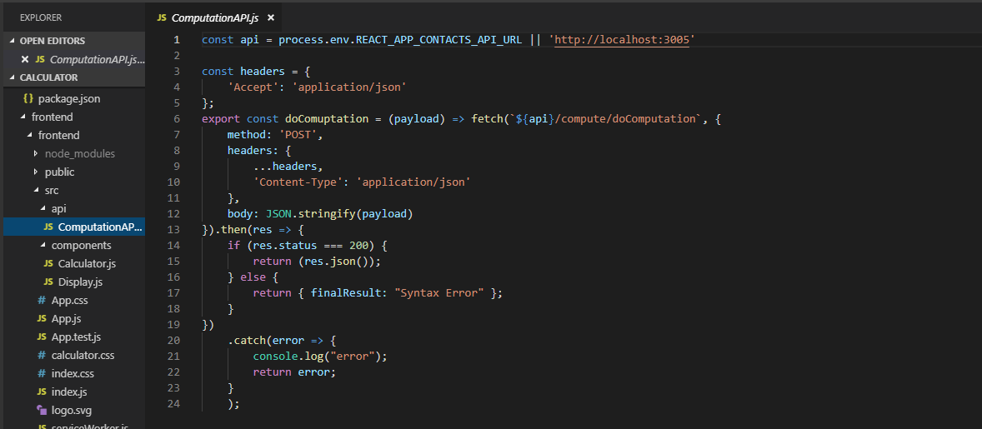

**3. Calculator Display.**

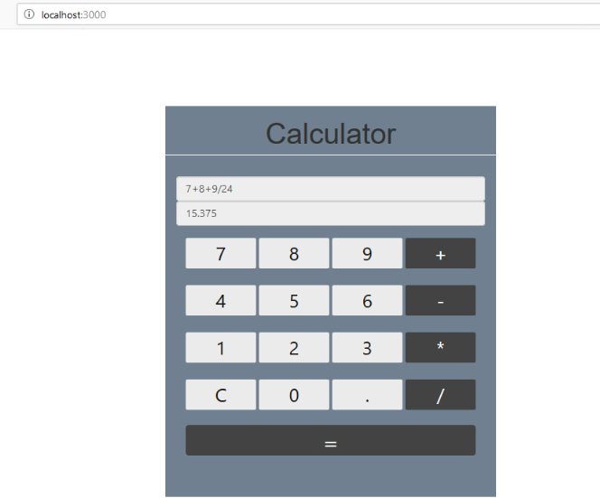

**System outputs:**

**1. node.js server running on port 3005 and react app running on port 3000.**

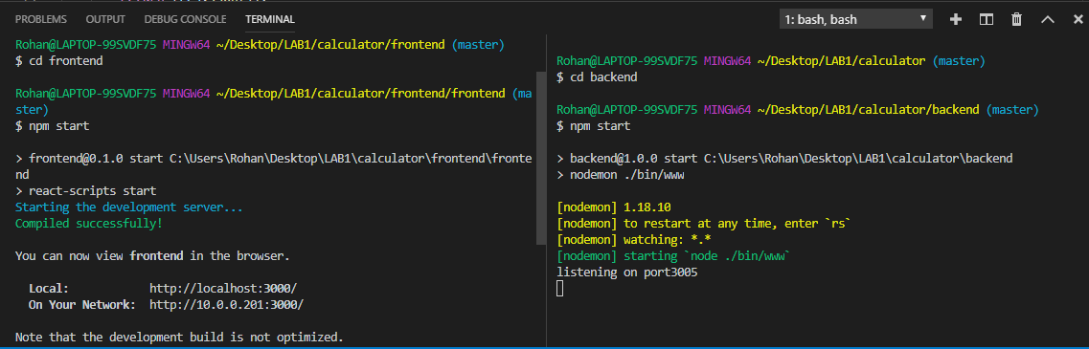

**2. React.js client**

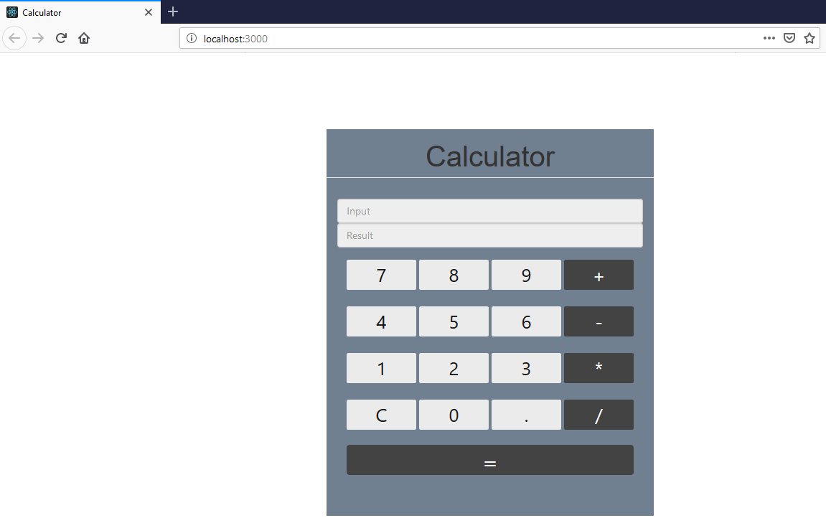

**3. Input:**

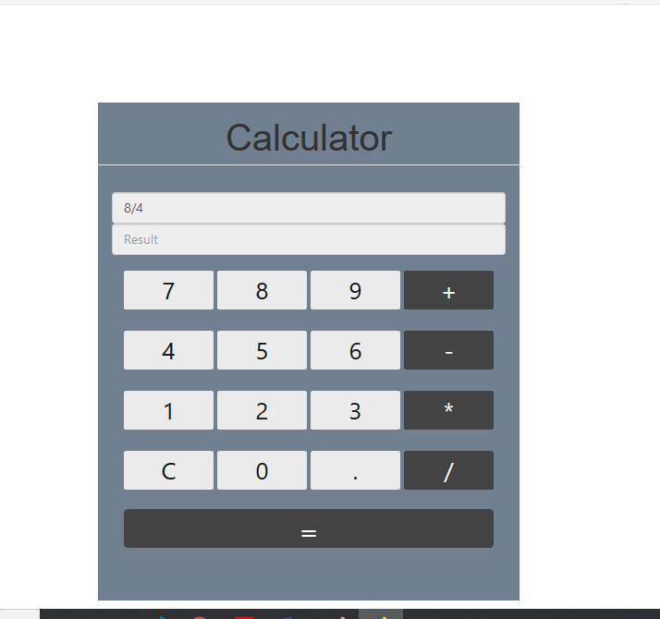

**4. Request on server:**

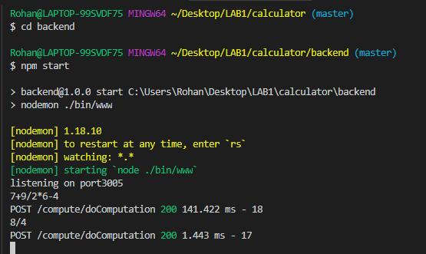

**5. Output to client:**

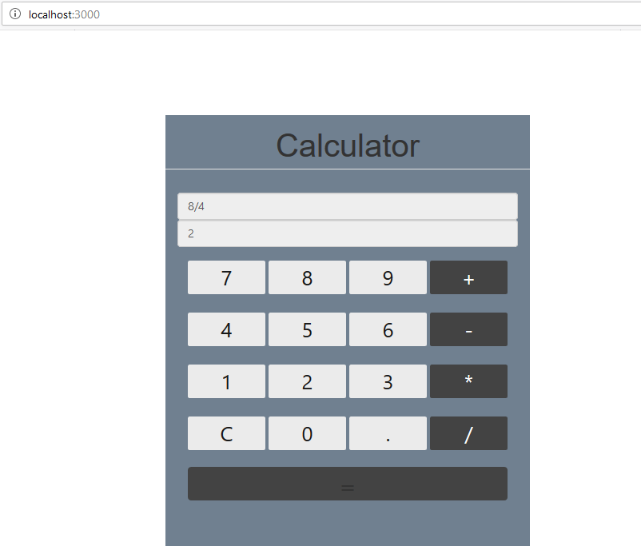

**Testing Using Jmeter:**

**1. 1000 calculator calls.**

**Printed Results: 1000 calculator calls**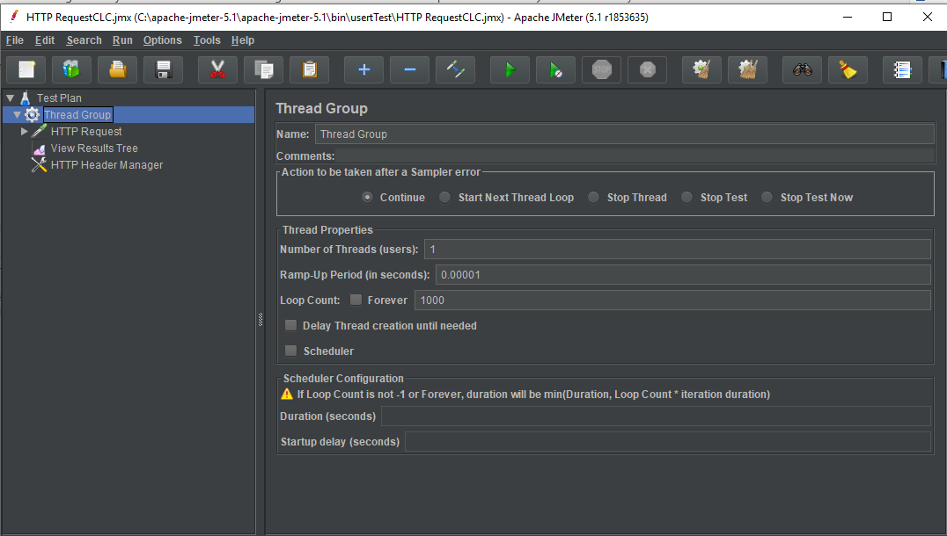

Printed results:

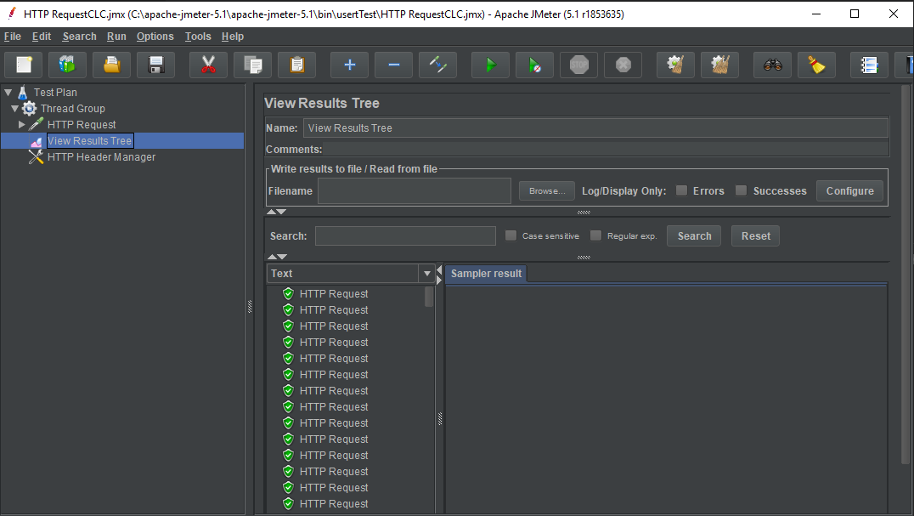

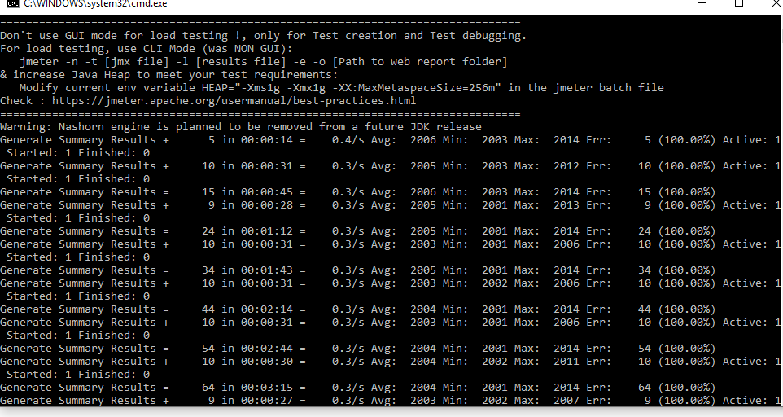

**Graph result:**

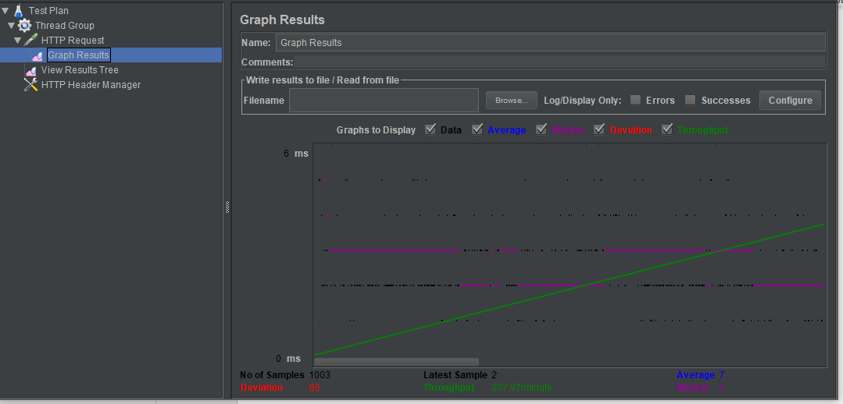

**Test 2: 5000 calculator calls**

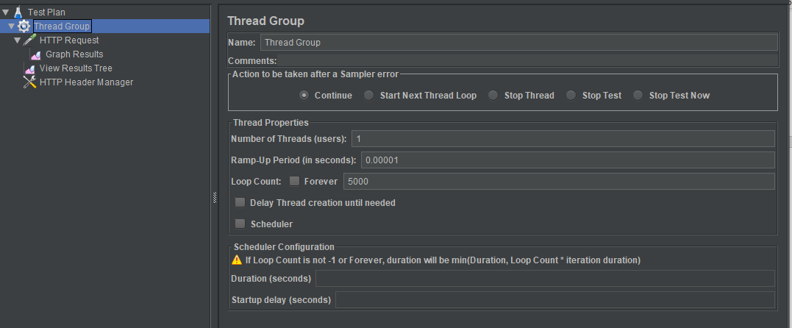

**Printed average time**

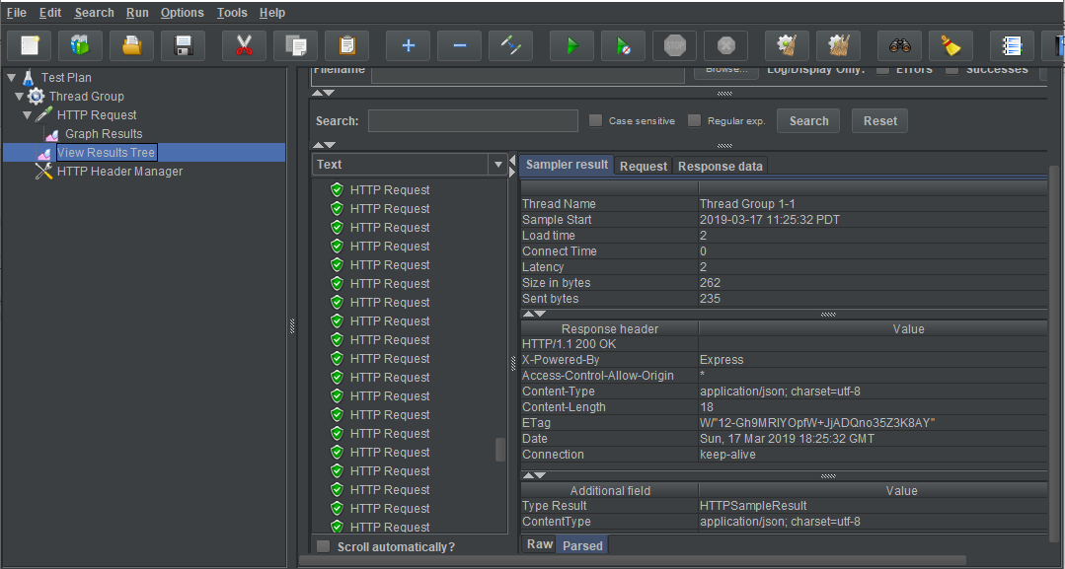

Graph Results:

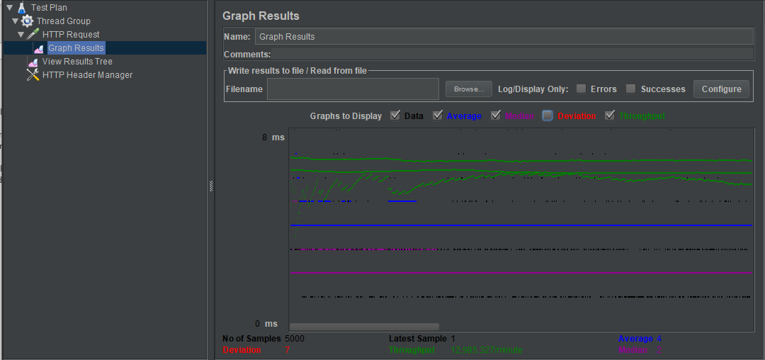

**Test:3 (100 users with 1000 calls each)**

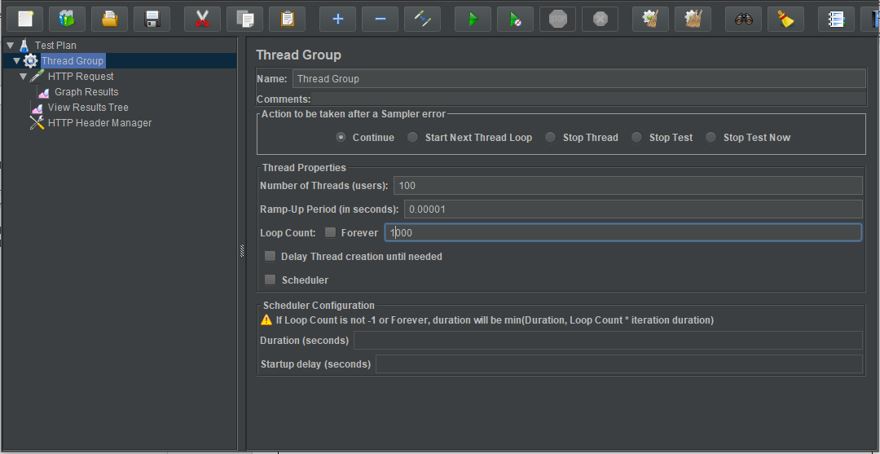

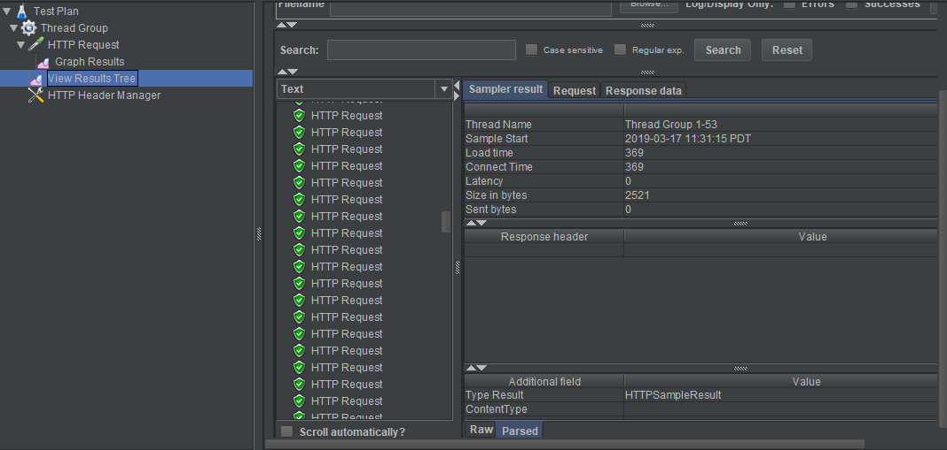

**Graph results:**

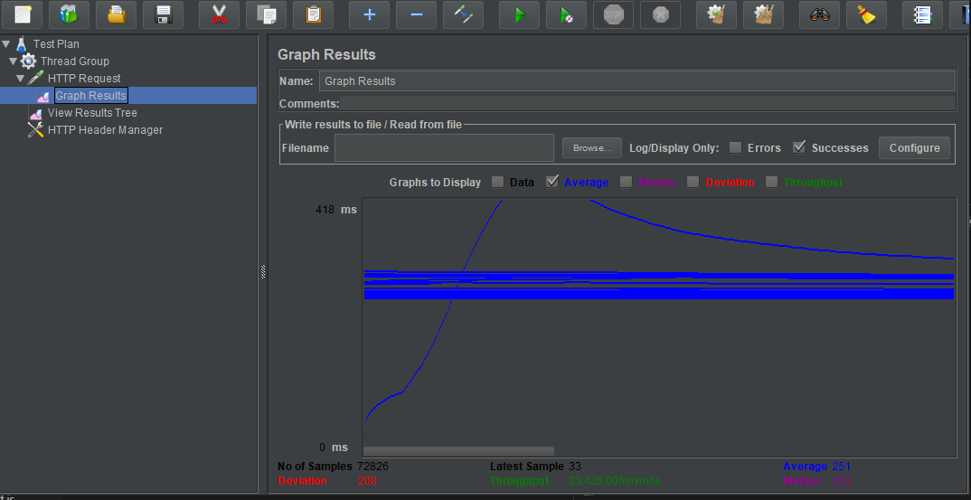

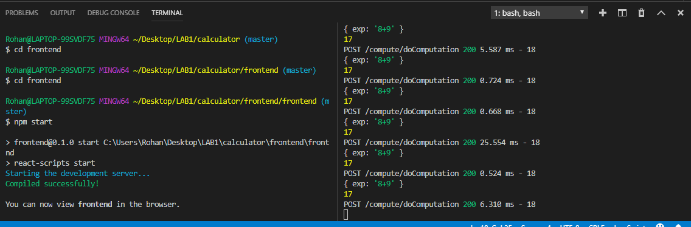

**Comparison of server performance:**

Graph results shows that server can easily handle 1000 user calls synchronously.

Whereas it takes more time to perform 5000 calls and graph results vary because of the variations in throughput.

For performing 100 concurrent users with 1000 API calls each, the server gets so many deviations and the average throughput time is increased. This is because of scalability and week asynchronous request handling.

Performance can be improved by giving more memory and connection pooling to server that can reduce throughput and content.

**Part-2: Prototype of SJSU Canvas Application using MERN (MySQL, Express.js, React.js, Node.js) .**

**Purpose:**

Developing a full stack single page application (SPA) to have proper understanding of the concept of MERN application development. By developing this application developer will be able to understand react and node environment and the structure of MVC and interaction with MySQL database.

**Goal:**

Design a single page web application of SJSU Canvas (a student portal) using MySQL as a model database, Express.js and node.js as server(controller) and React.js (view) as a client user interface.

**Primary Structure:**

1. Node.js server for handling server request

2. MySQL schema for storing data of application

3. React client user interface for application view on client side.

**Users of application:**

1. faculty (with admin rights)

2. Student

**Functional Requirements:**

**1. RESTful service on server side:**

Server should be able to perform below tasks.

1. **Basic user functionalities**

1. Sign up new user (Name, Email and password)

2. Sign in existing user

3. Sign out. 4. Profile (Profile Image, Name, Email, Phone Number, About Me, City, Country, Company, School, Hometown, Languages, Gender)

5. Users can update Profile anytime.

**2. Students**

1. Student should be able to search for all the courses by term, by id or by course name. Should have filter like id greater than a value.

2. Student should be able to enroll for a course, drop a course and waitlist a course when full**.**

**3. Faculty:**

1. Faculty should be able to create a course with following fields

a. CourseId

b. CourseName

c. Course Dept

d. CourseDescription

e. CourseRoom

f. CourseCapacity

g. Waitlist capacity

h. courseTerm

2. Faculty should be able to give permission codes for the waitlisted students.

**4. Course Details:**

**Student:**

Student can view his grades in the course.

Student should be able to submit his assignment.

Student should be able to view all his submissions per assignment.

Student should be able to take quiz.

Student should be able to view all announcements

Student should be able to view all the people under that course.

Student should be able to view and download lecture notes and files

**Faculty:**

Faculty should be able to create Assignments and Quizzes.

Faculty should be able to view and download submissions from students.

Faculty should be able to make announcements

Faculty should be able to view all students registered for that course.

Faculty should be able to grade assignment submitted by students.

Faculty should be able to upload lecture notes and files

Faculty should be able to remove a student from the course.

**5. Home**

1. Student should be able to view all the courses he/she has registered.

2. Faculty should be able to view all the courses created by them.

**6. important Note:**

User must login to have access to application. and password must be encrypted.

Should perform connection pooling (in-built in MySQL) for database access.

**Proposed System Design:**

MySql Database

React Client

Express Server

HttpRequest Update Database

HttpResponse

**Implementation:**

**1. Database Structure:**

**Schema: Canvas**

**Data Dictionary:**

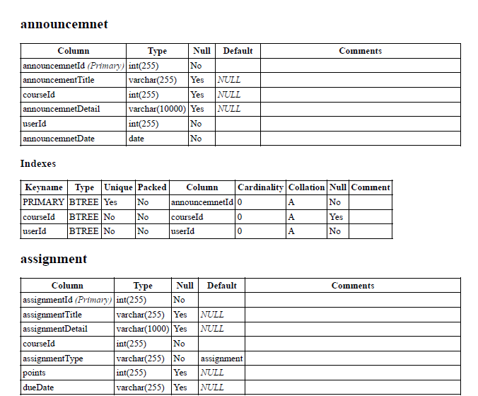

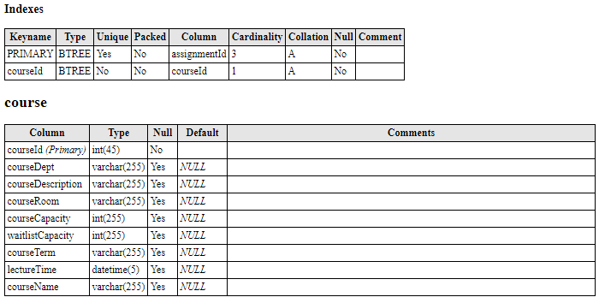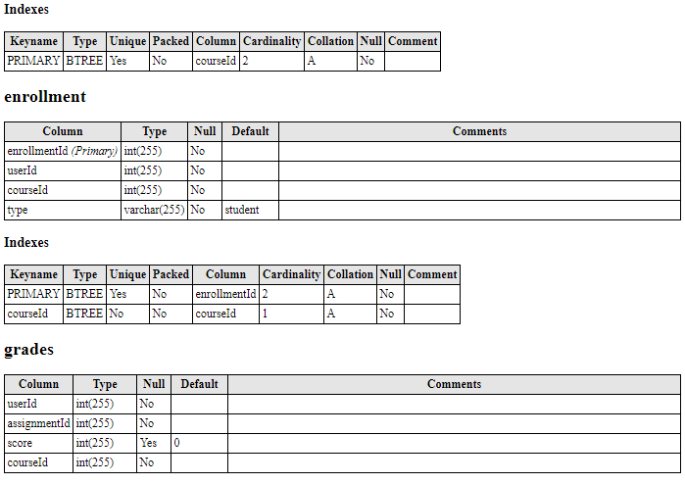

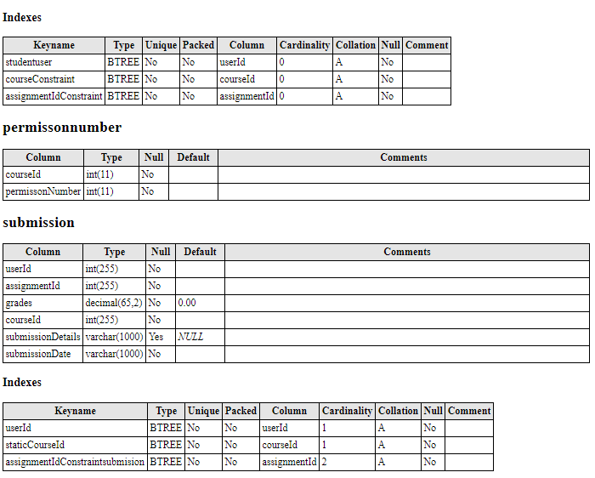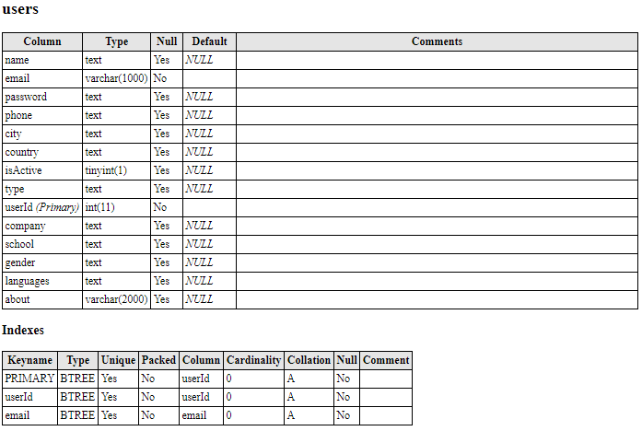

**Schema Structure:**

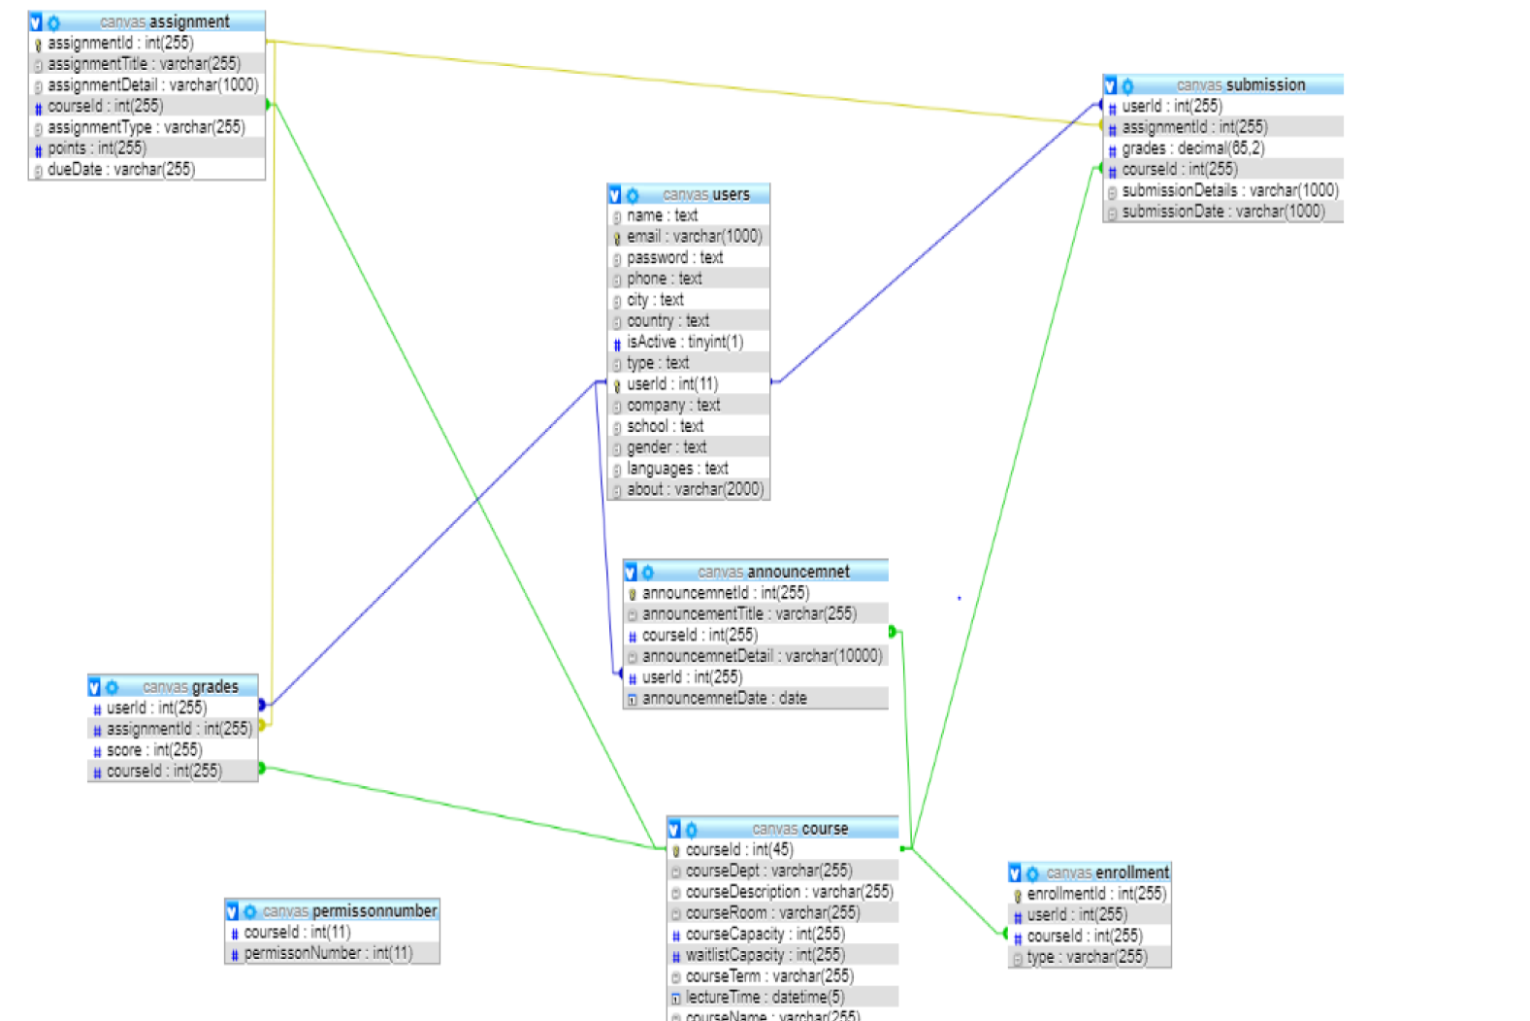

**2. RESTfull Services node.js server:**

**1. index.js**

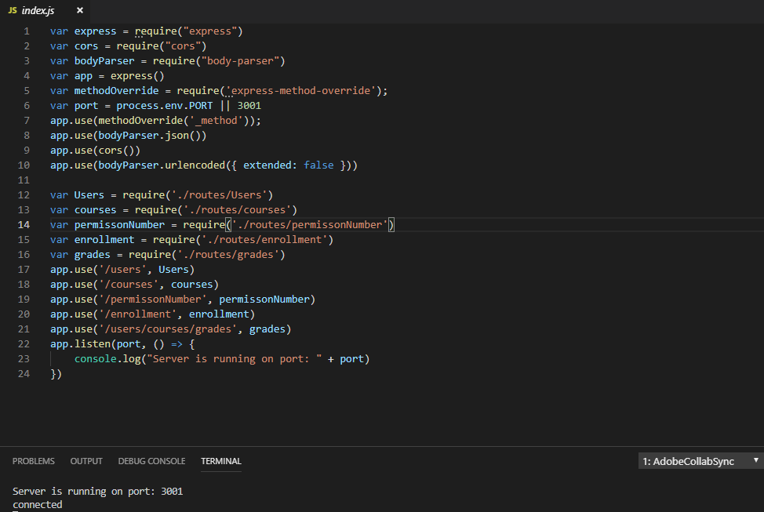

**2. Users Signup:**

Create a signup form which will take input from client and add the user is database if not already exists.

This will contain basic user details like Name, Email, password, type etc..

It encrypts the password using bcrypt and generates a Hash value and stores the Hash value in database.

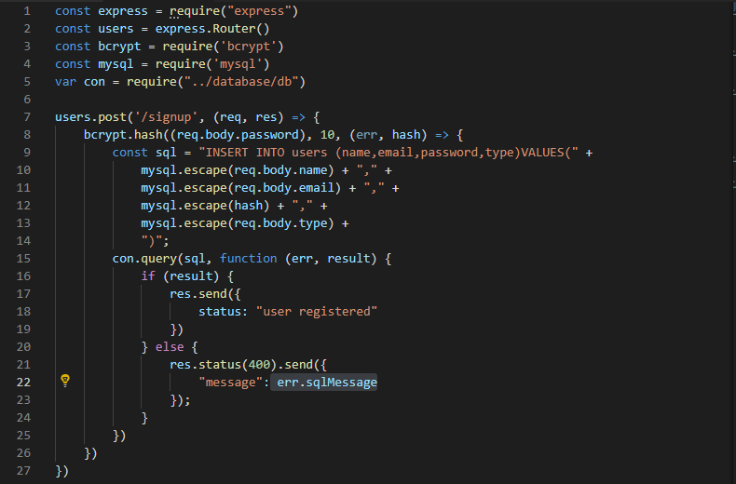

**3. Login:**

When users enter the site address it will directly land on the login page where he will enter a username and password.

On entering user credentials, server will generate a hash value of entered password and match it with the saved hash value of the password in database.

If the credentials match, then user will land on his home page or Dashboard page where he will see all his registered courses.

Use of Json-web-tokens: for making our session strategy horizontal I have used json web tokens which will generate a web token when user signs in and store that value in its local storage. Now every time when a user sends any request, it will have a JWT with it. The server matches the token with its own token if both values match then only server will responds. This way the session can be maintained and user authorization is also possible.

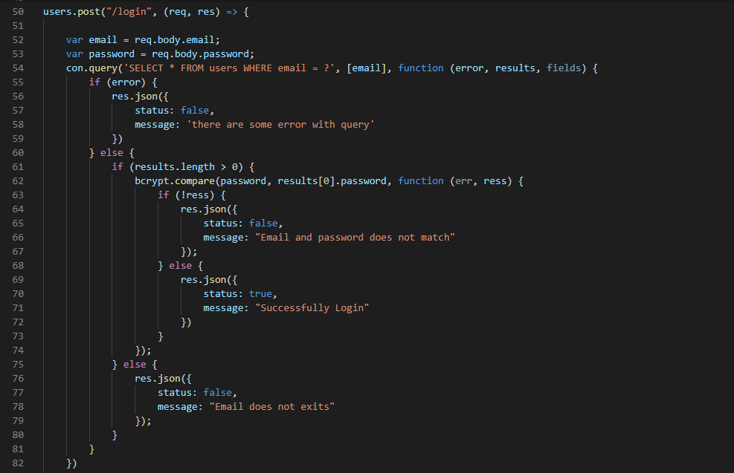

**4. User profile:**

User can update his profile at any time by going to profile page and update the details button.

This is a very basic details form on which the post request will be made, and user will be able to update his details accordingly.

User can not update his password from this page.

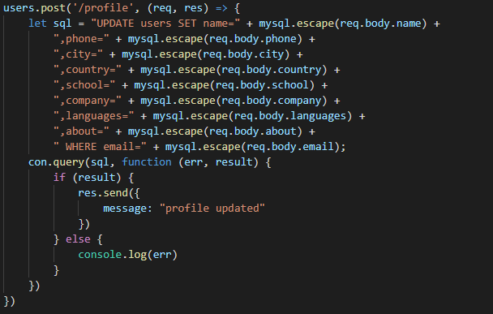

**Dashboard:**

Student will be able to see all the courses he has enrolled for and faculty will be able to see all the courses he/she has created on dashboard.

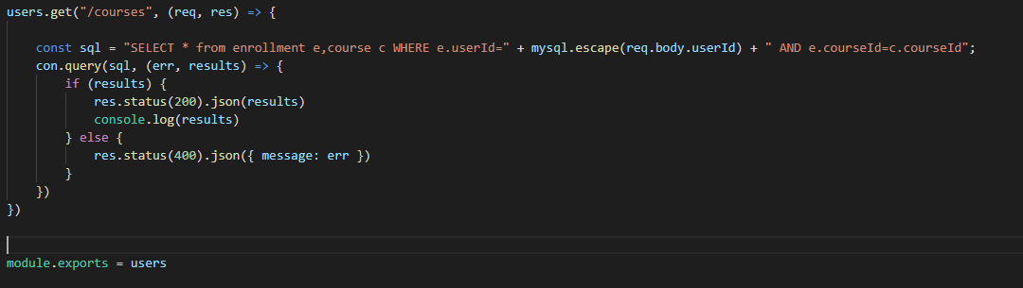

**Student can see all the available courses:**

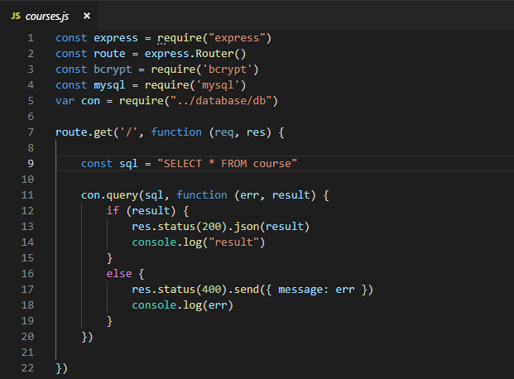

**Enrollment:**

Student can enroll in desired course from the list and remove his self from the list.

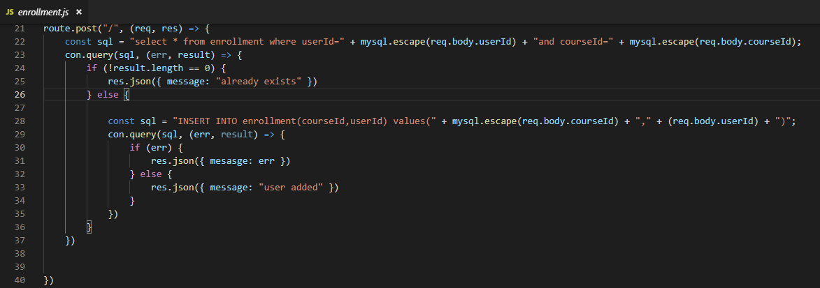

**Enrolled students:**

Student and faculty can see all the registered people for that course in the enrolled students tab.

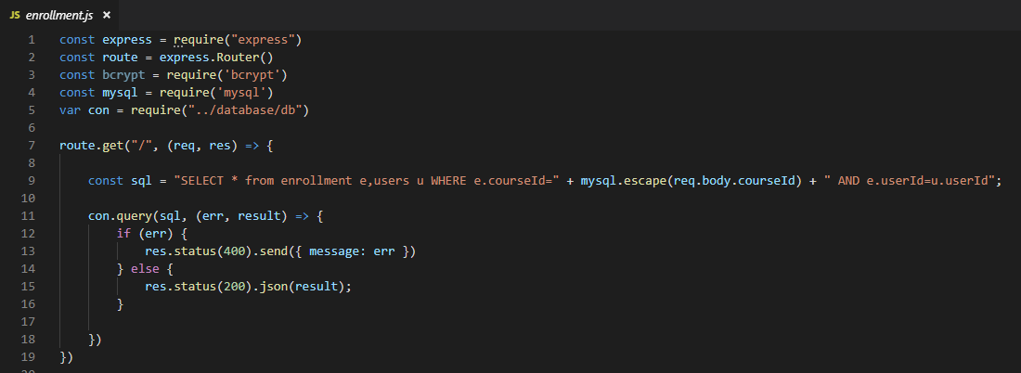

**Remove enrollment:**

Faculty can remove student from the course and student can remove his self from the course as and when needed.

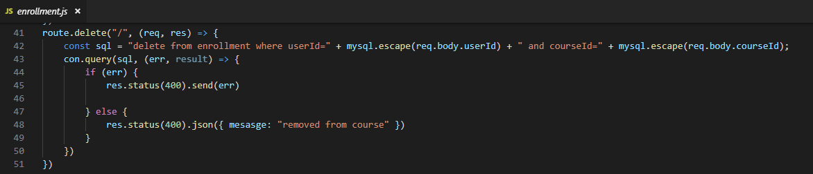

**Announcements:**

Faculty must be able to create announcements under any course.

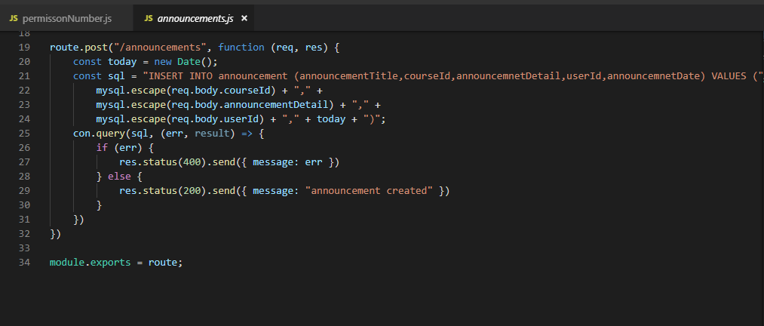

**View announcements:**

Students and faculty must be able to see all the announcement made under course.

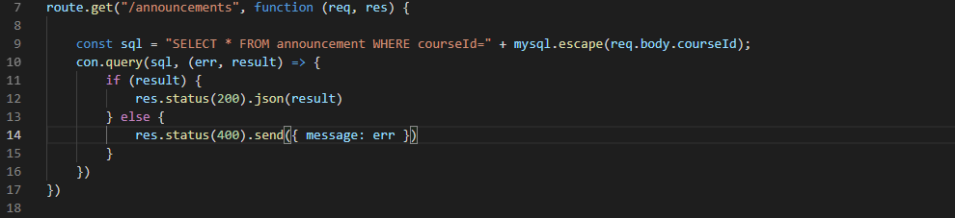

**Permission Number:**

Faculty must be able to generate random and unique permission number for every course based on the waitlist student capacity.

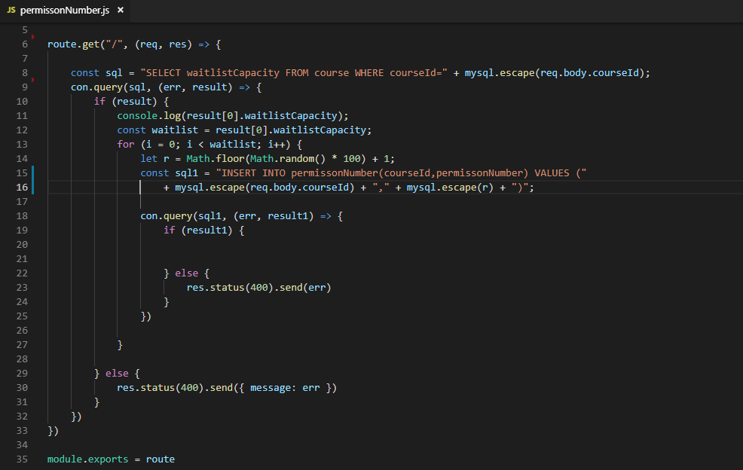

**Show Assignments:**

User must be able to see all the assignments posted under the course

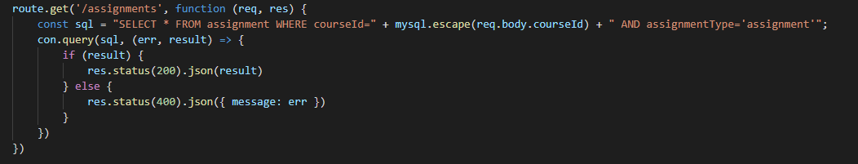

**Create an Assignment:**

**Faculty must be able to create a new assignments and add the values like assignment title, assignment type, assignment details, due date, total points etc.**

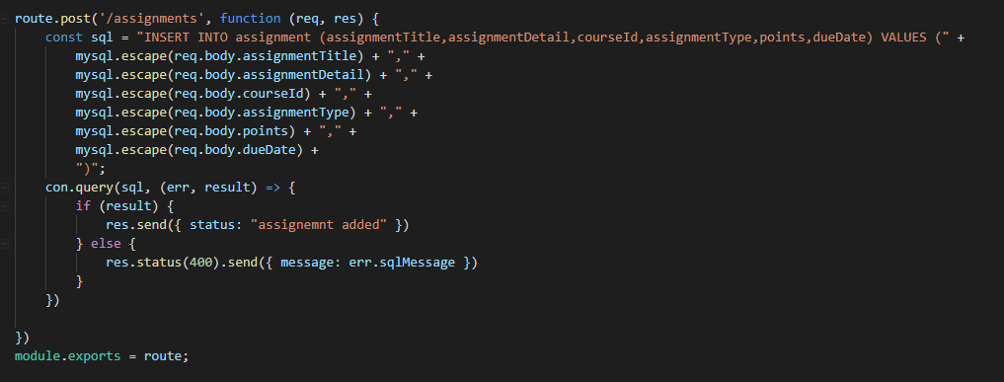

**Submission:**

**Student must be able to submit his assignments by uploading file or any suggested method given in assignment details. This should contain details like assignment Id, student Id, submission date etc.**

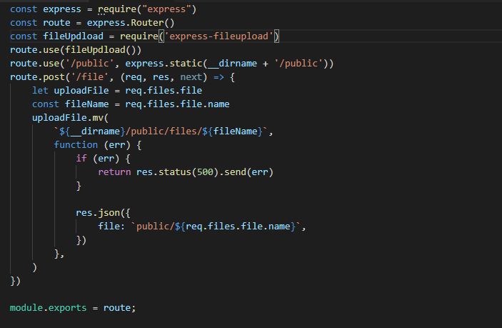

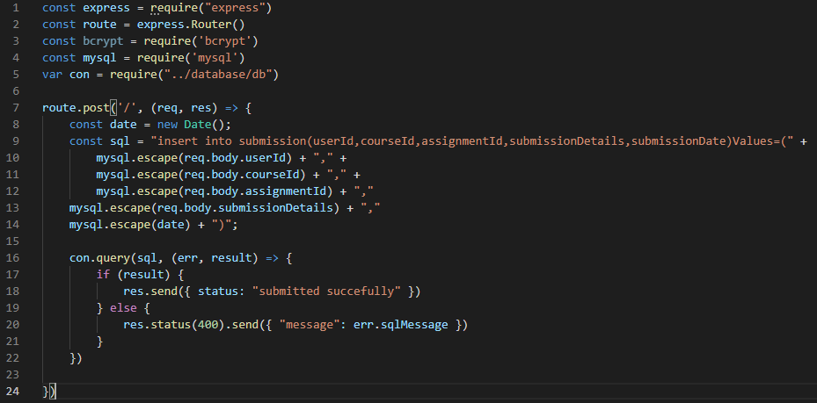

**View submissions:**

**Faculty must be able to see all the submission done by students by assignment Id .And student should be able to see all his submissions.**

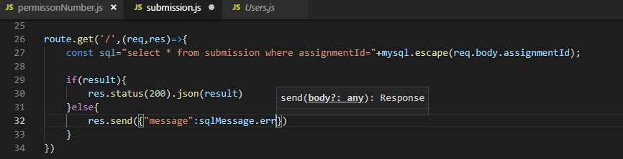

**Grades:**

**Grading assignment:**

**Faculty must be able to grade an assignment submitted by students.**

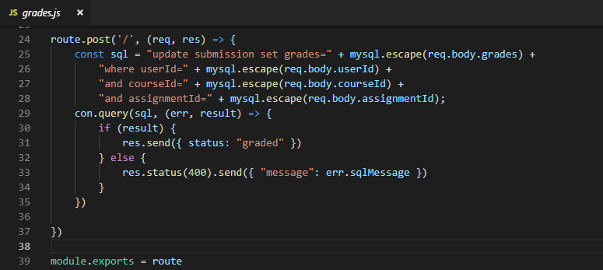

**View Grades:**

**Student must be able to see his grades in grades Tab where he can see all his submitted assignments and its grades.**

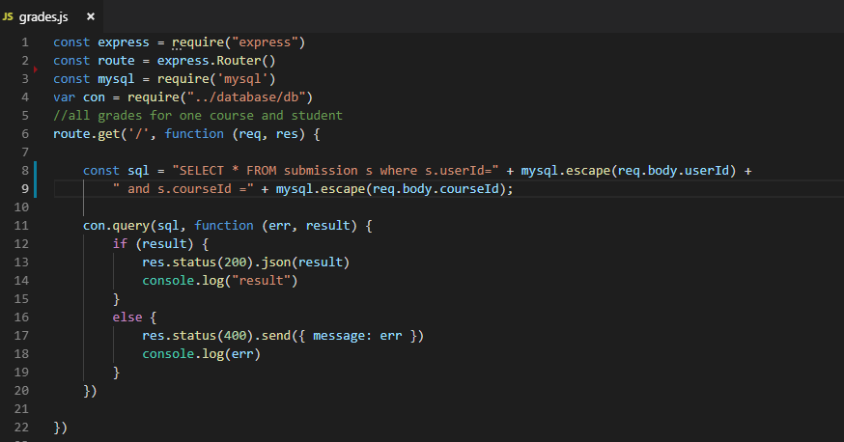

**Connection pooling:**

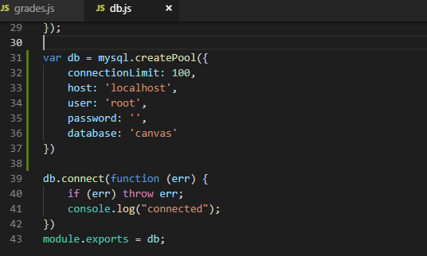

**Encryption:**

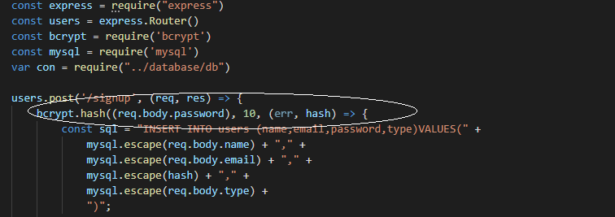

**React Client UI:**

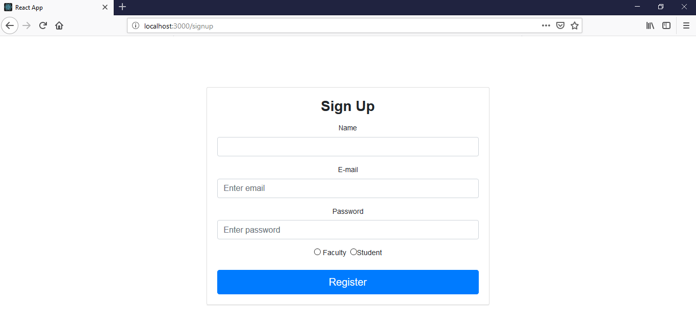

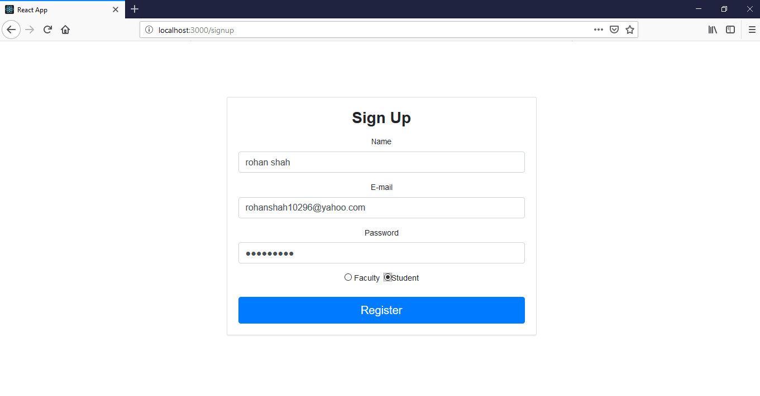

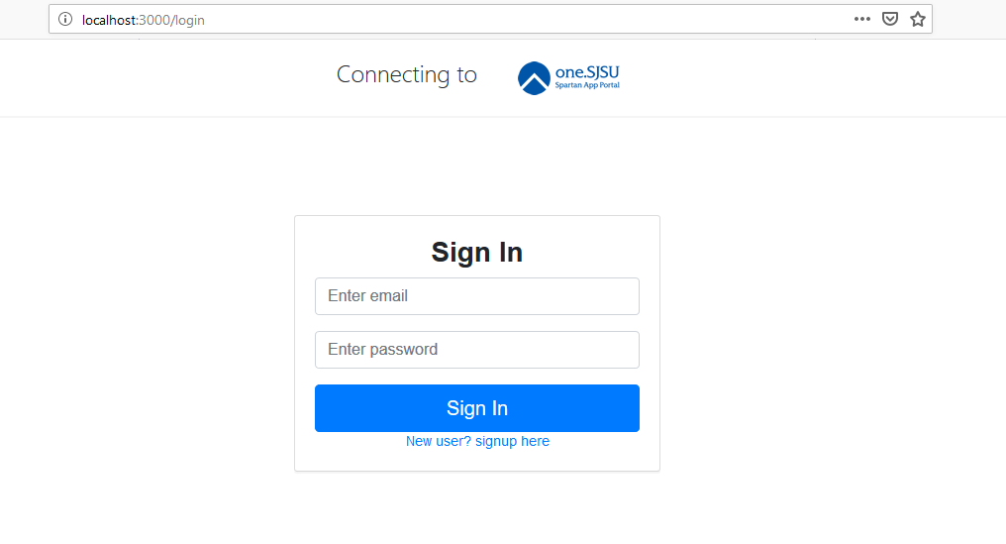

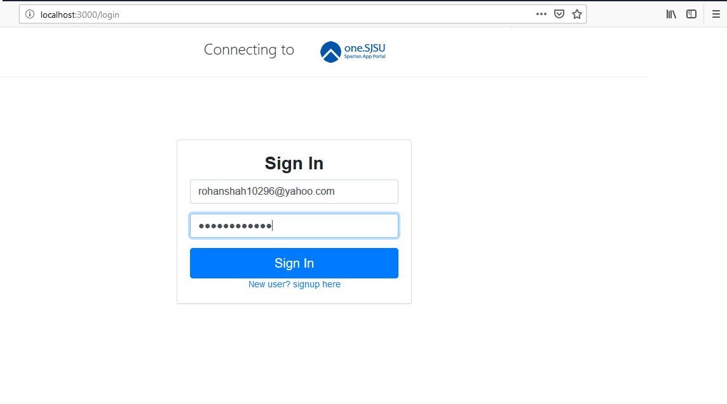



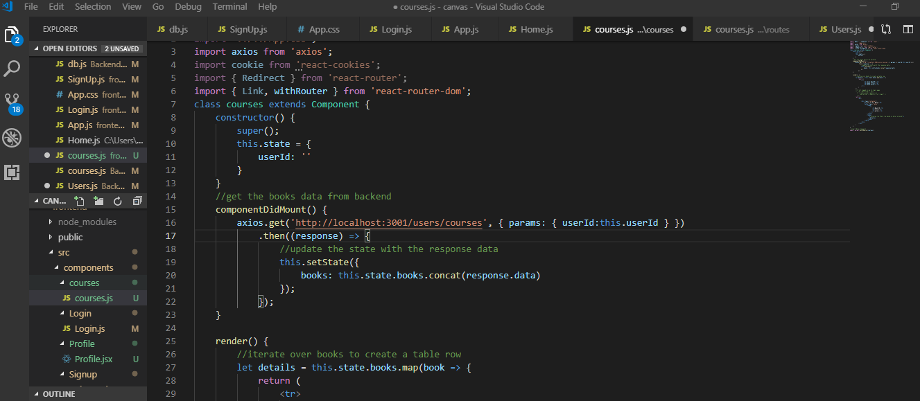

**TESTING:**

**JMETER Testing.**

**1. With Connection pooling.(pool size 1000)**

**1. 100 concurrent users:**

**Graph result:**

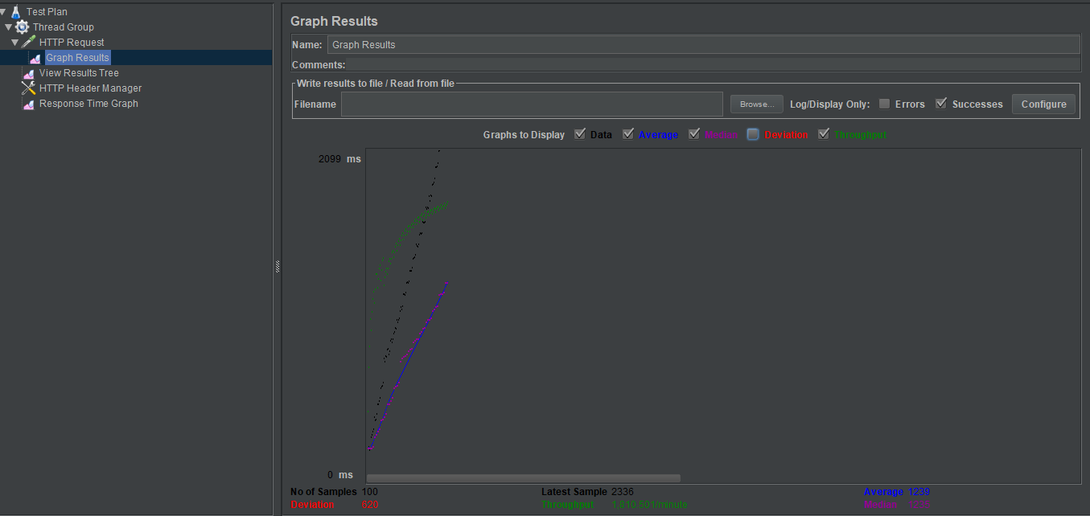

**Response time Graph:**

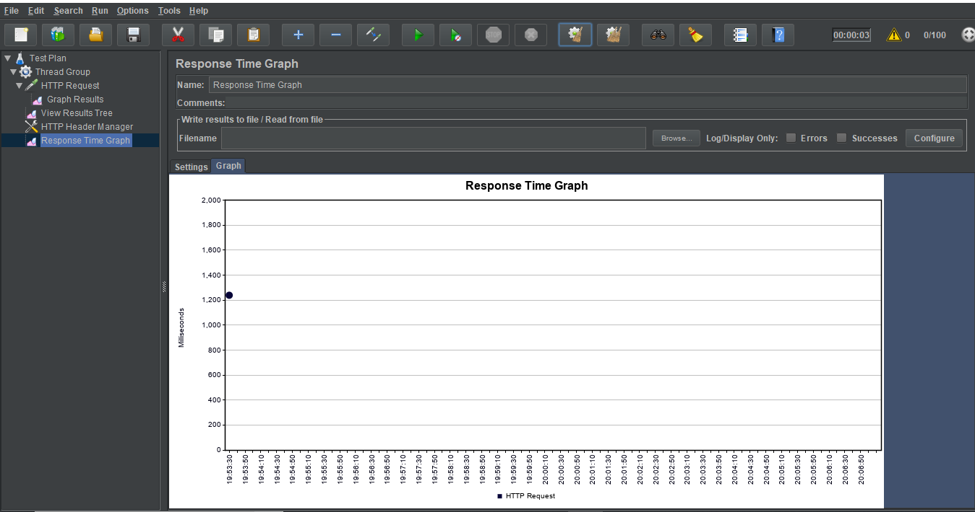

**Result tree:**

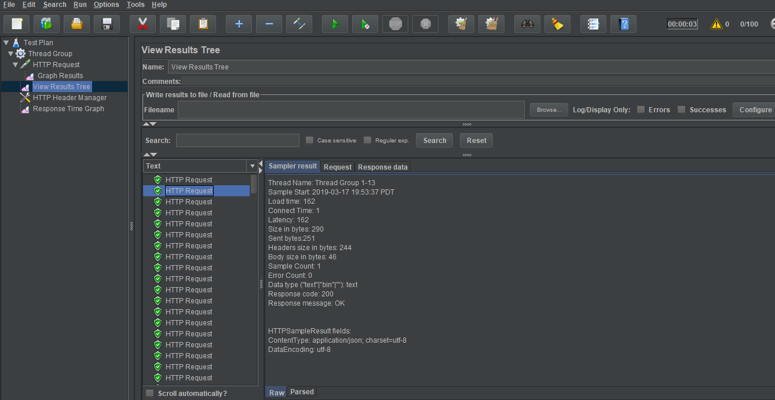

**200: Concurrent users:**

**Graph results:**

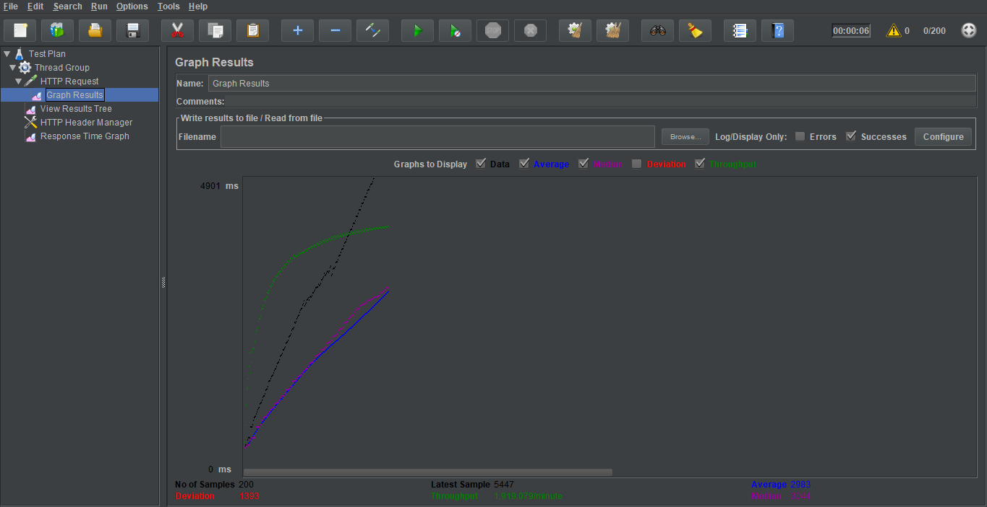

**Response Time Graph:**

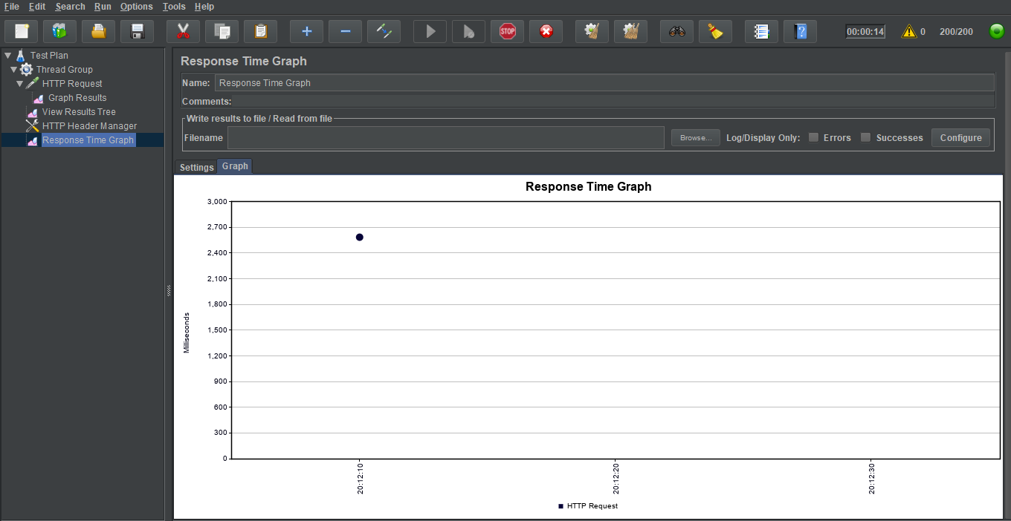

**Result Tree:**

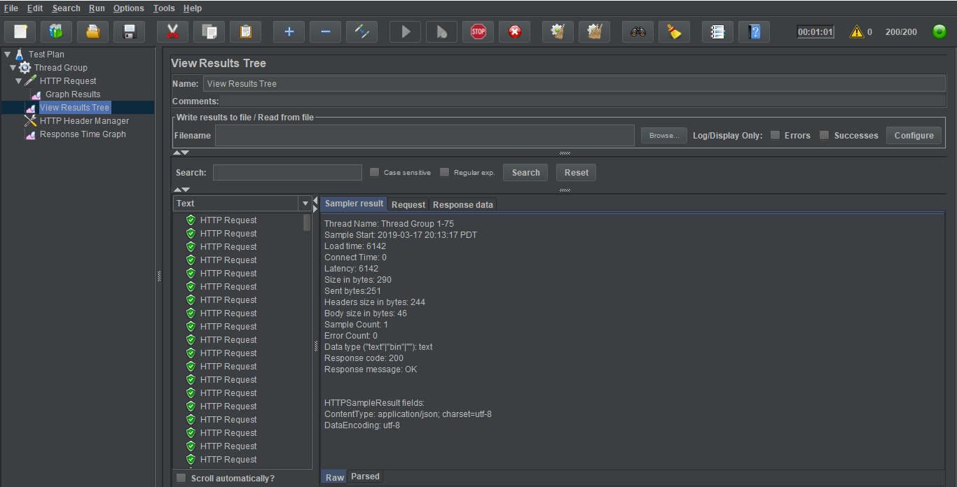

**300 concurrent users:**

**Graph Results:**

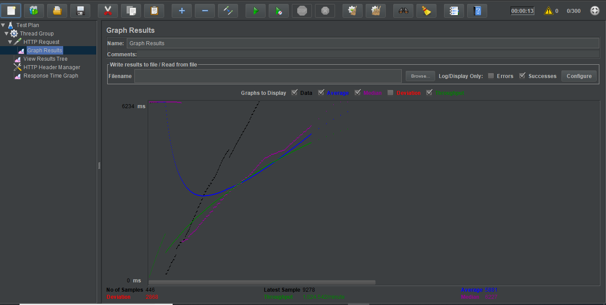

**Response Time Graph:**

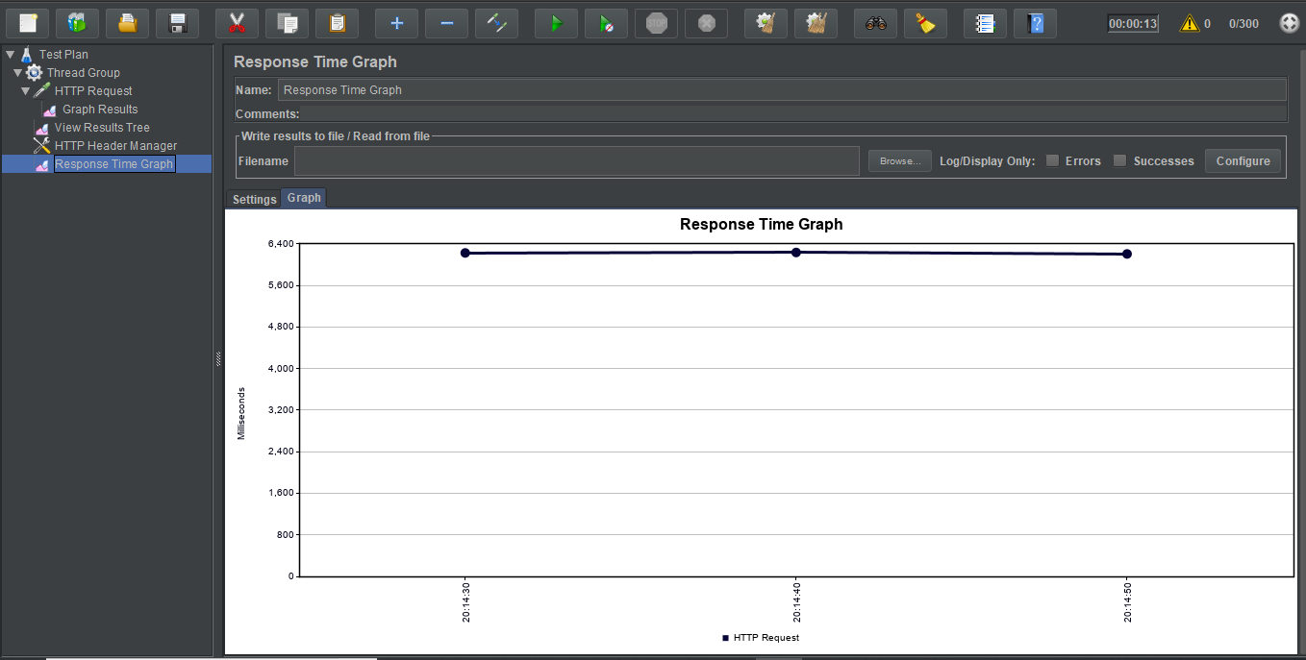

**Result tree**

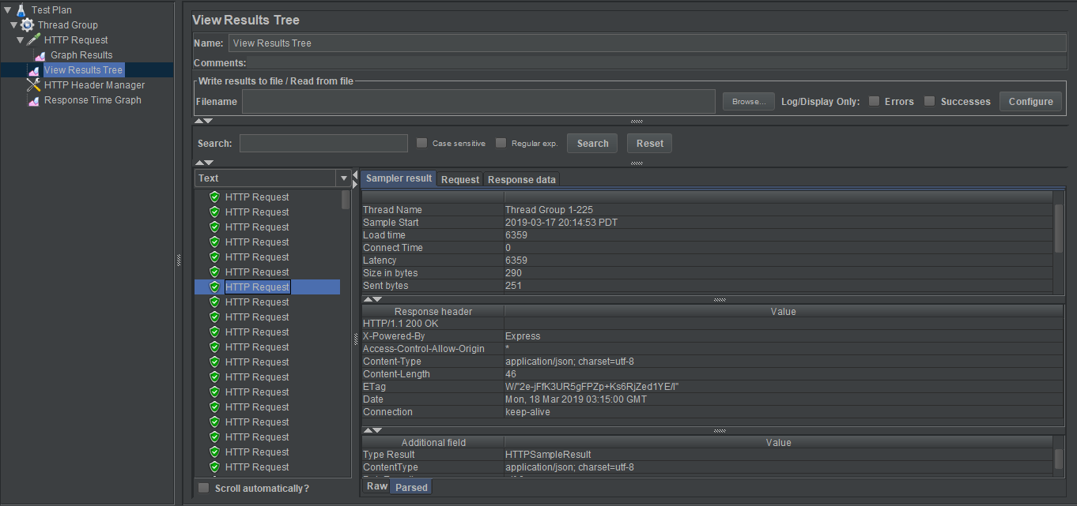

**400 Concurrent users:**

**Graph results:**

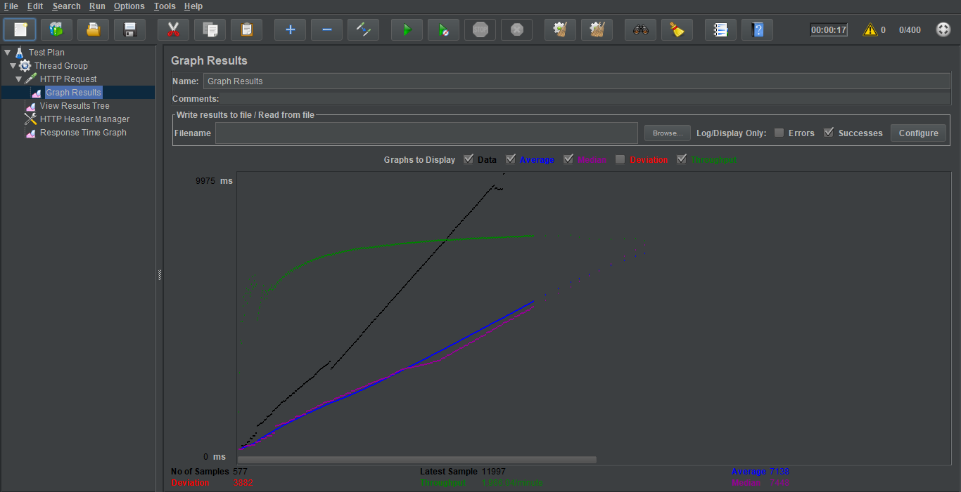

**Response Time Graph:**

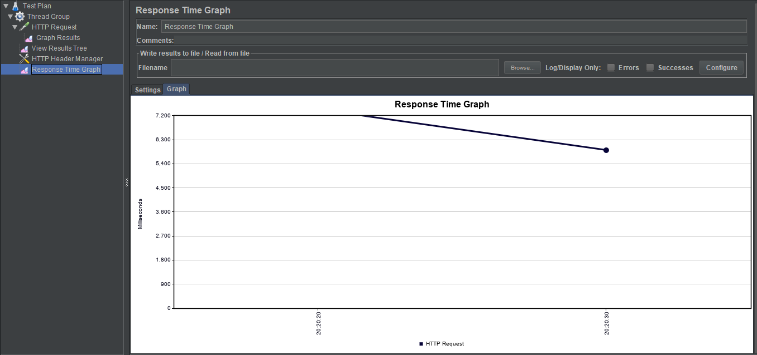

**Result tree:**

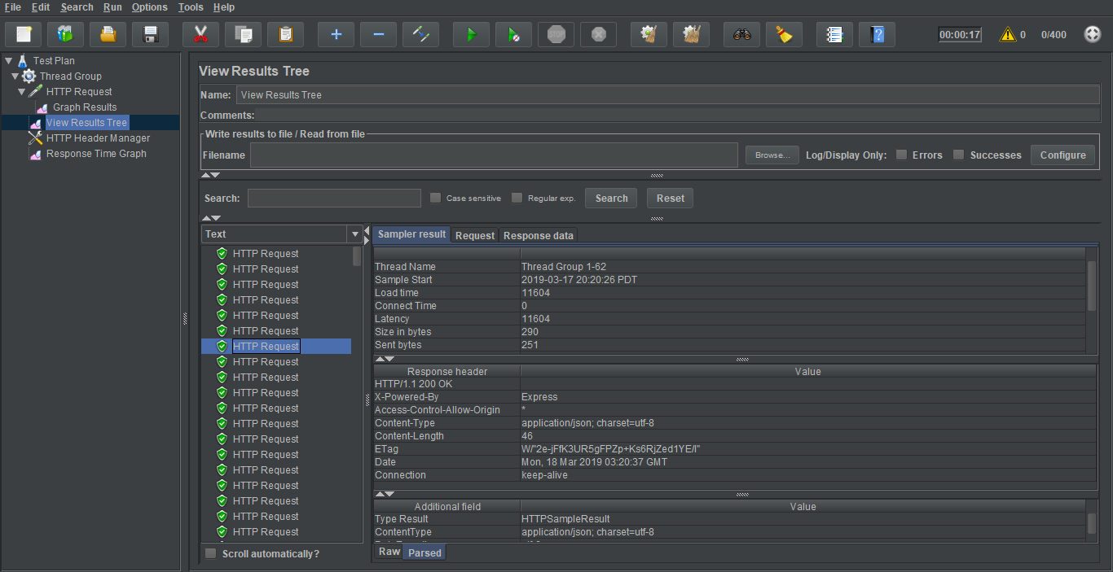

**500 Concurrent users:**

**Graph Results:**

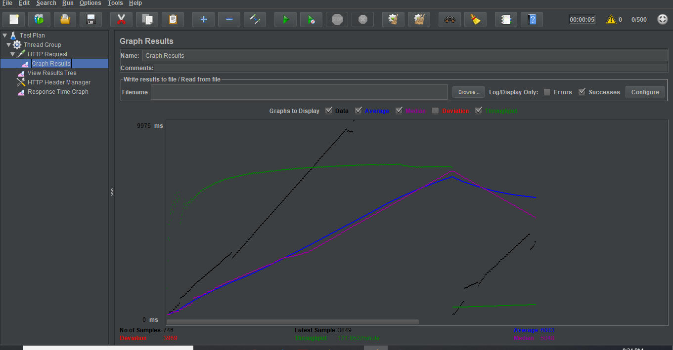

**Response time graph:**

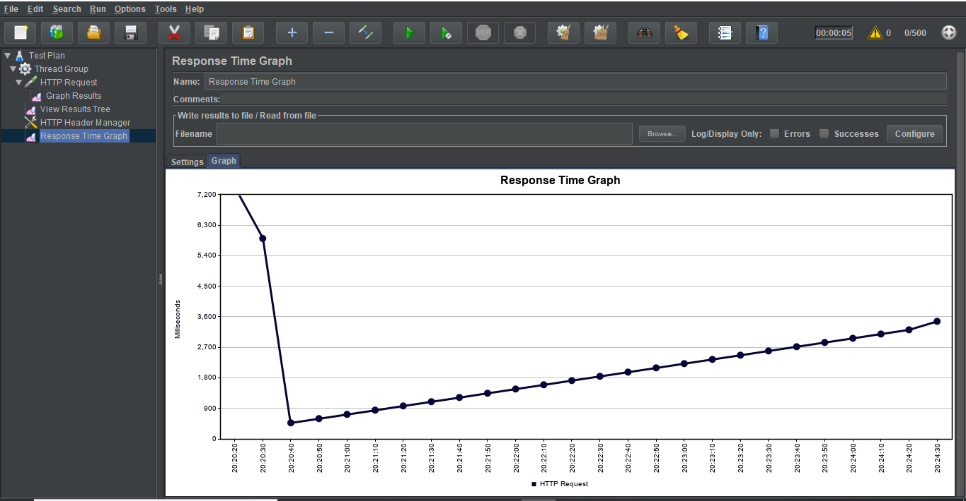

**Result tree:**

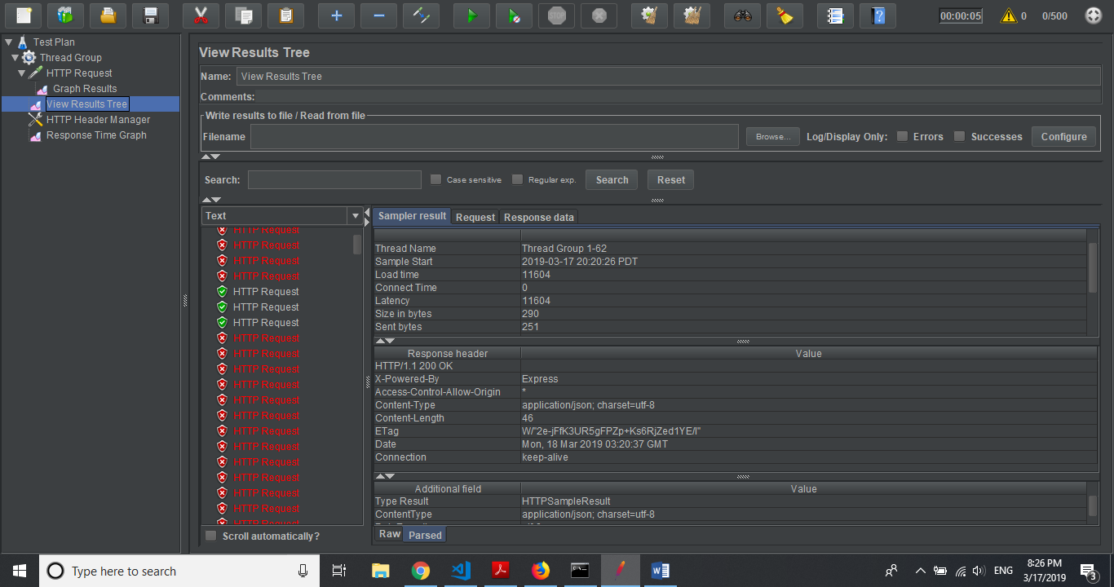

**Without connection Pooling:**

**100 Concurrent users:**

**Graph Results:**

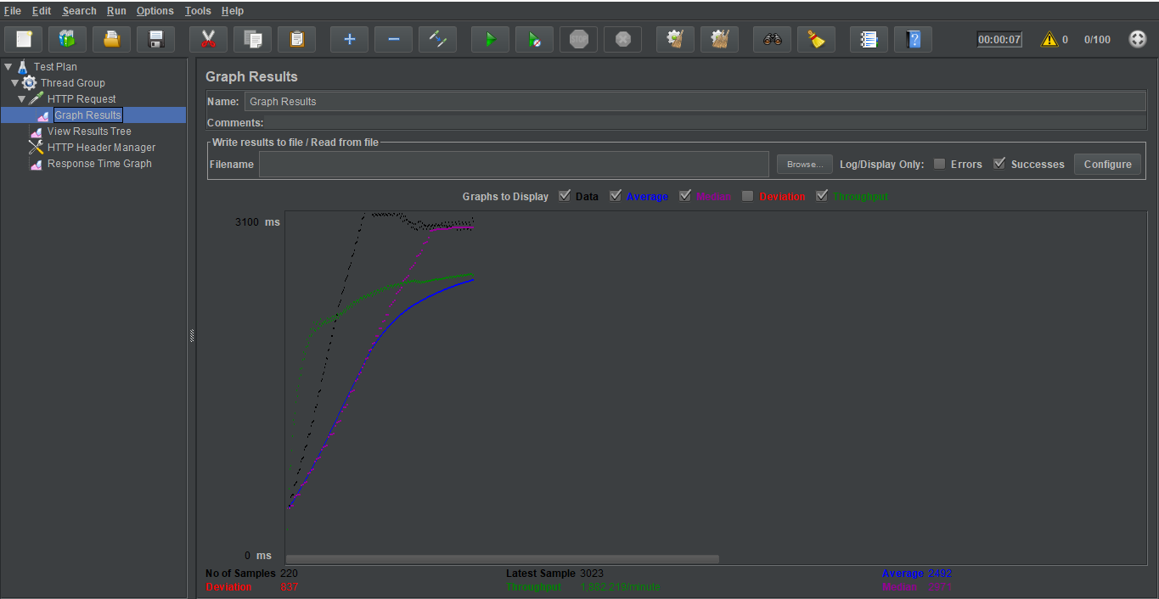

**Response time graph:**

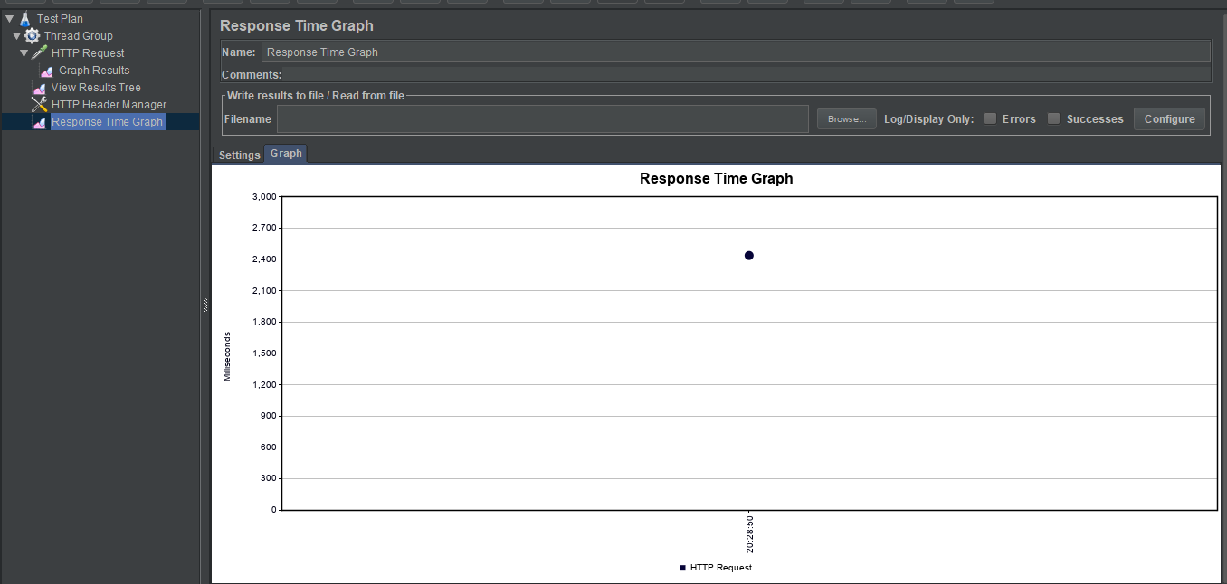

**Result tree:**

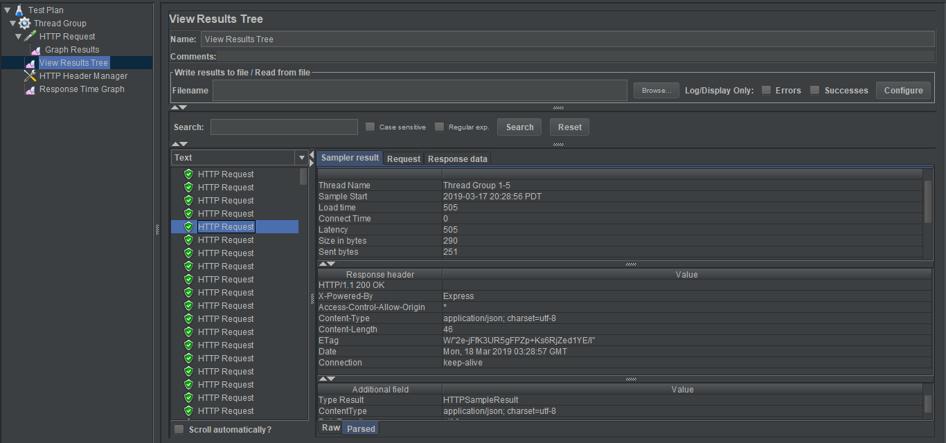

**200 Concurrent users:**

**Graph results:**

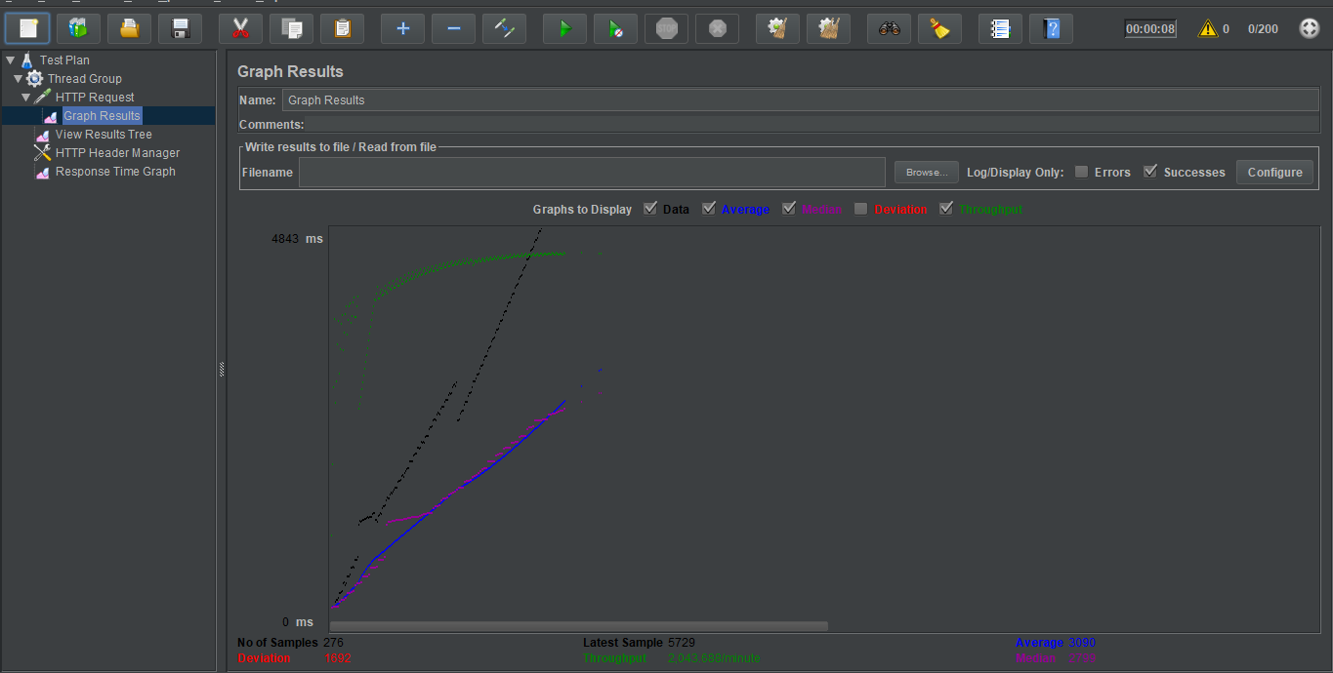

**Response Time Graph:**

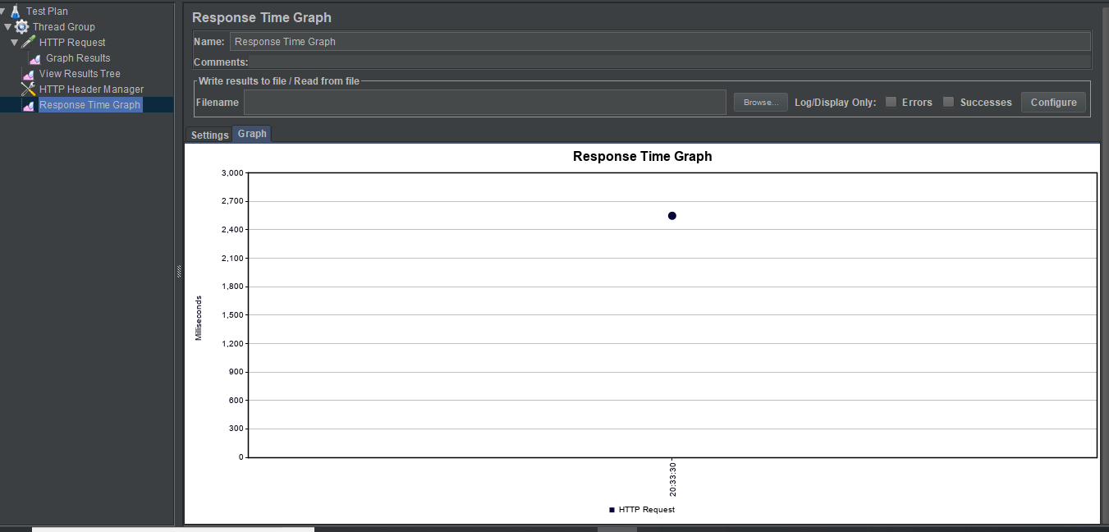

**Result tree:**

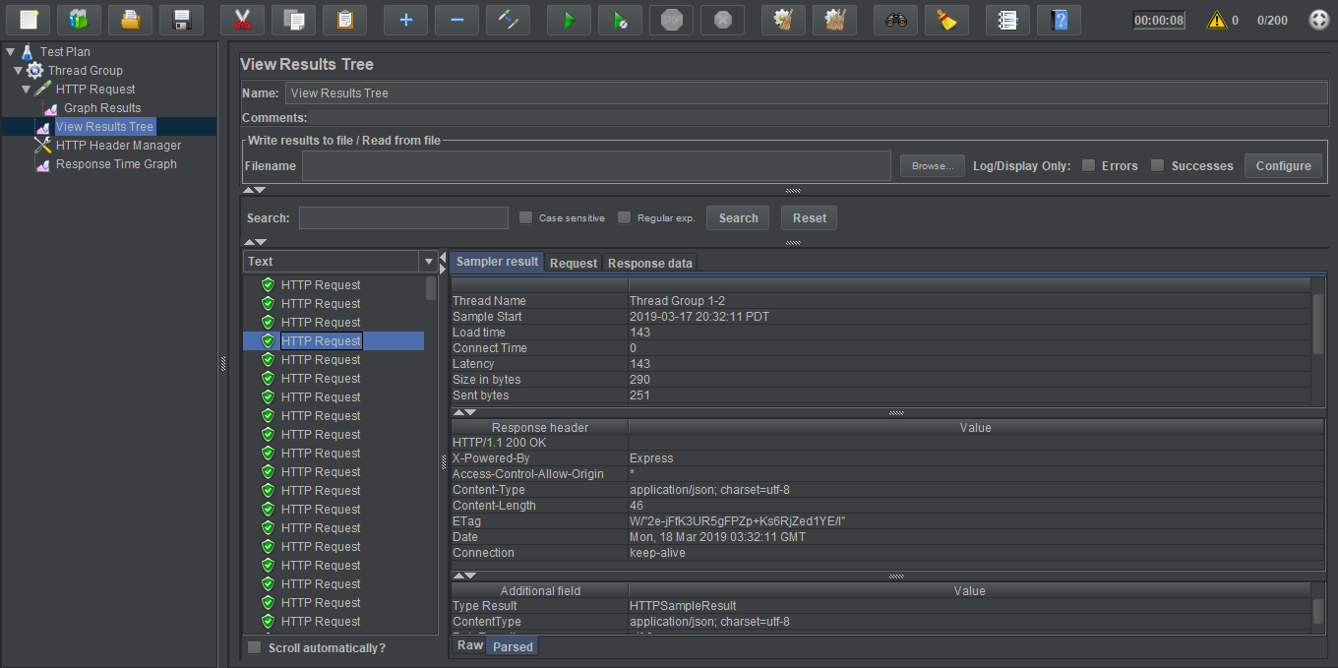

**300 concurrent users:**

**Graph Results:**

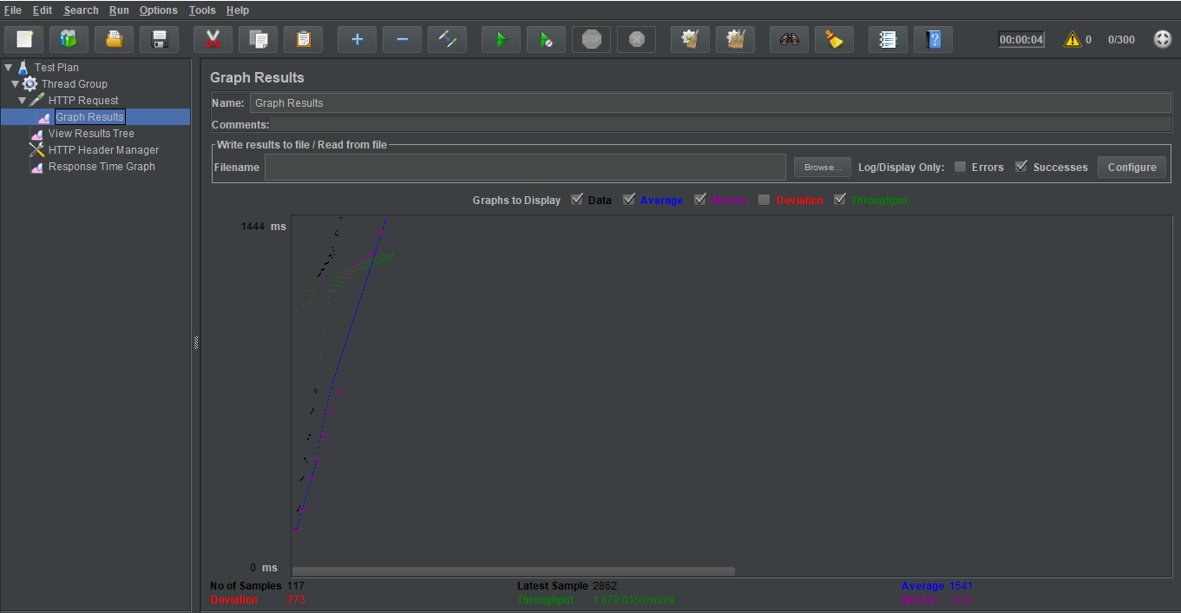



**Response Time Graph:**

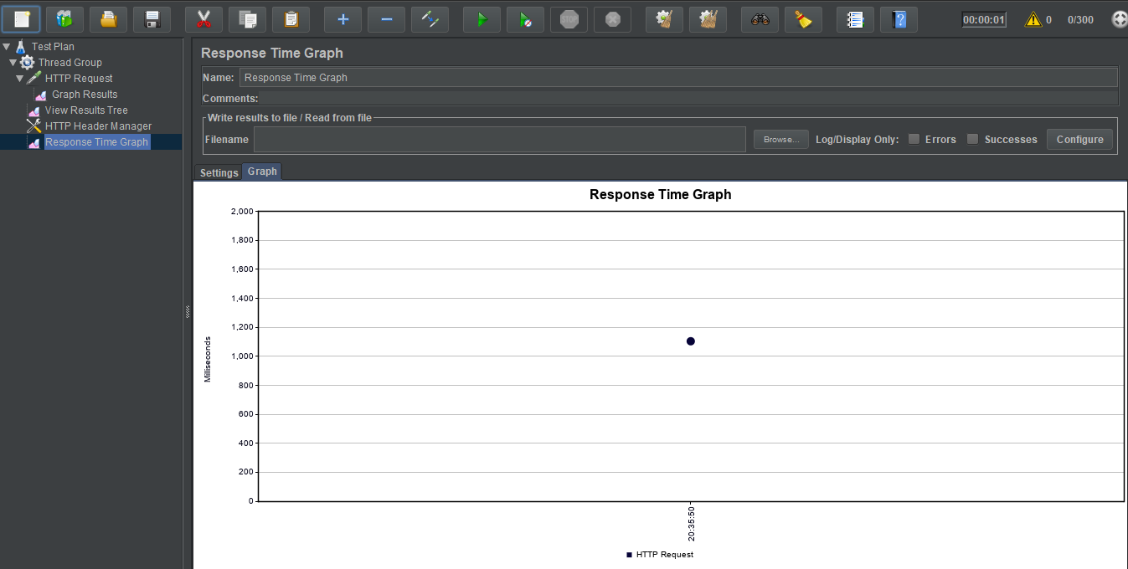

**400 Concurrent users:**

**Graph Results:**

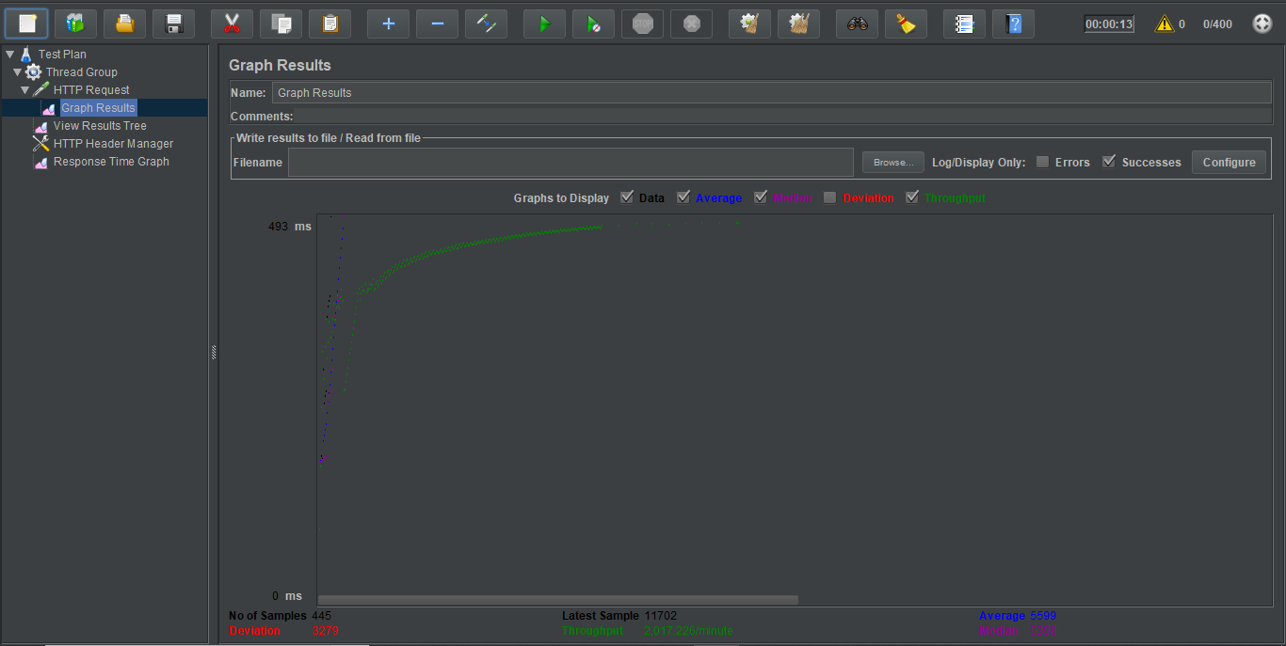

**Result tree:**

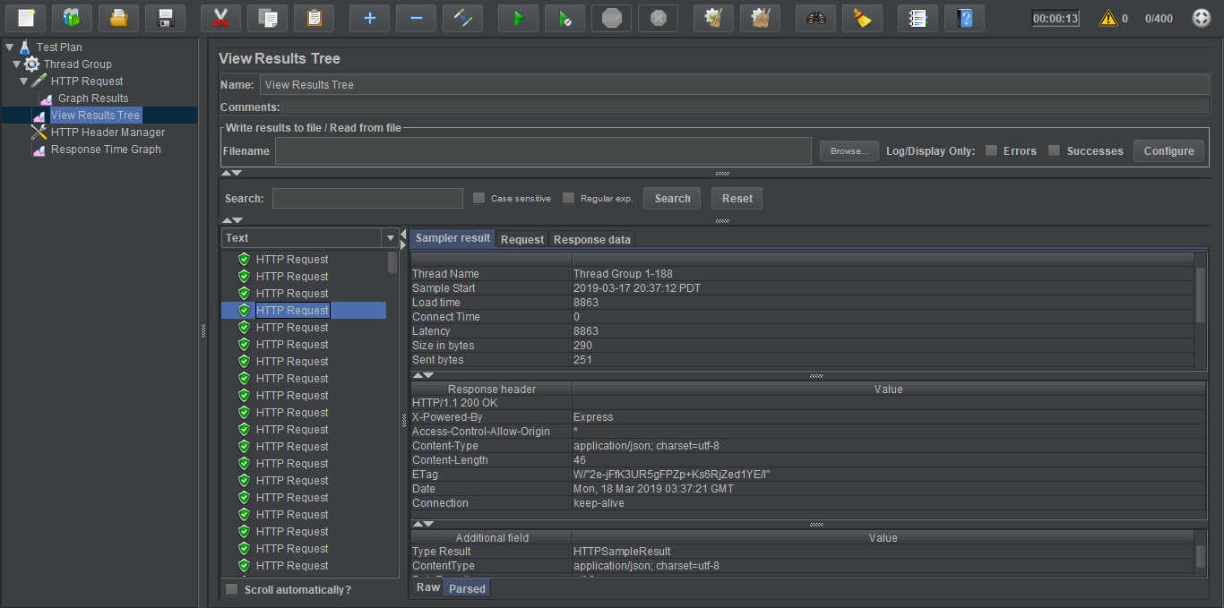

**500 Concurrent users:**

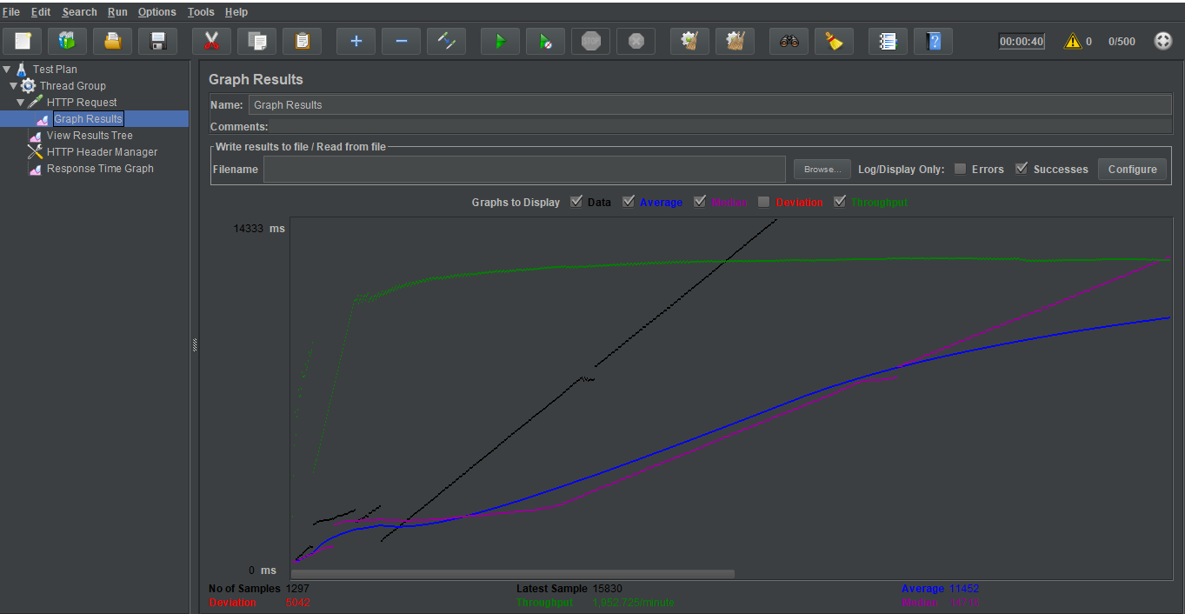

Response Time Graph:

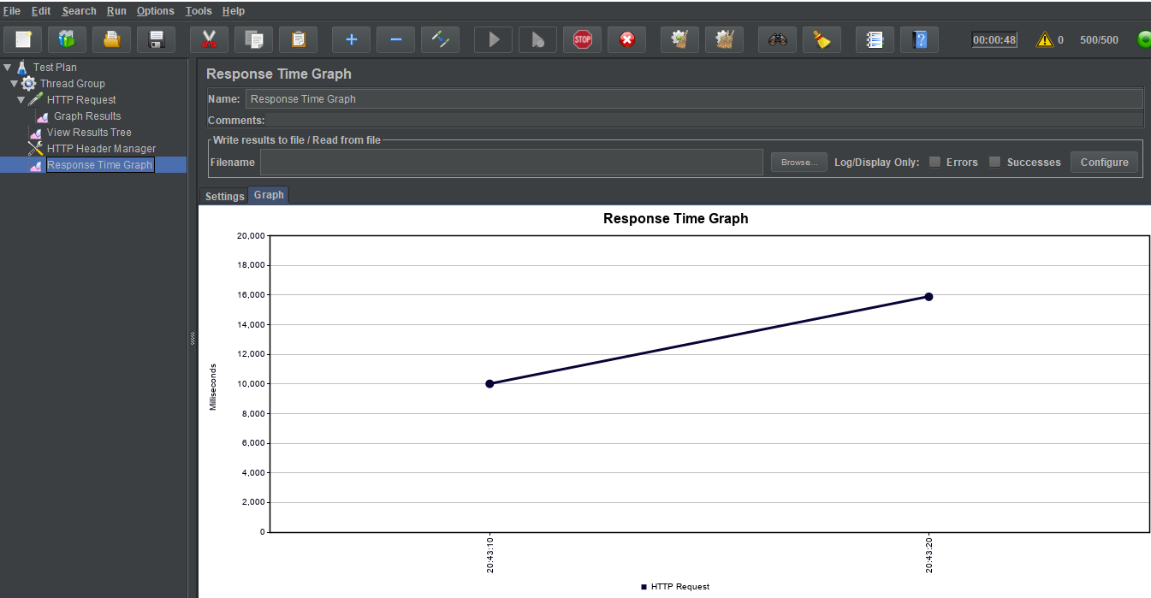

**Result Trees:**

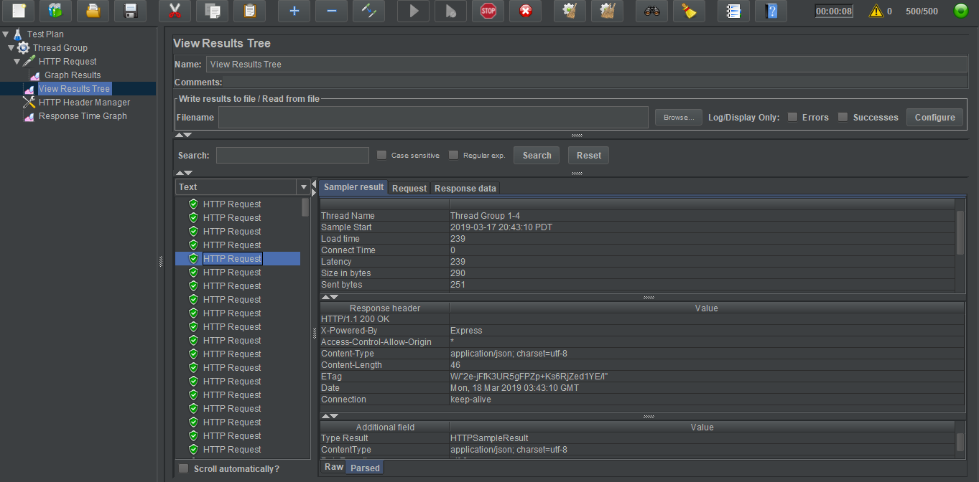

**Questions and Answers:**

**1. Explain the encryption algorithm used in your application. Mention different encryption algorithms available and the reason for your selection of the algorithm used.**

* I have used symmetric block cipher algorithm library Bcrypt which uses Blowfish encryption algorithm.
* It generates a secured Hash value by multiple rotation and symmetric key encryption, and it is free for use.

**Other available Encryption algorithms:**

1. AES (Advanced Encryption standard)
2. DES or D3ES (Data Encryption Standard)
3. Two FISH
4. IDEA
5. MD 5 (messaging Digest)
6. HMAC
7. RSA Security.

**Why Bcrypt?**

* It is an adaptive hashing algorithm that uses a blowfish symmetric cipher to encrypt.
* Its most important feature is that It uses a Key Factor that adjusts the cost of hashing. The ability to increase the cost of hashing i.e. increase the time and power for hashing is what makes Bcrypt more powerful. This process gets very slow.
* It can expand its Key Factor to compensate for increasingly more-powerful computers and effectively “slow down” its hashing speed. Changing the Key Factor also influences the hash output, so this makes Bcrypt extremely resistant to rainbow table-based attacks. Newer computers can attempt to guess the original input of the hash.
* Bcrypt is slower then SHA2 and it is adaptive where as SHA2 is not adaptive. speed is the key factor for using Bcrypt over other algorithm as in terms of encryption, the slower is better.

**2. Compare the results of graphs with and without in-built MySql connection pooling of database. Explain the result in detail and describe the connection pooling algorithm if you need to implement connection pooling on your own.**

**Answer:**

**Results of graphs with and without connection pooling:(100 users)**

1. **With connection pooling(graph results):**



1. **Without connection pooling.**



With Connection pooling: (time Graph):



**Without Connection pooling:**



**Comparison:**

It is clearly seen from the graphs that average response time decreases when we use the connection pooling where as without connection pooling, the connection time increases and average response time increases.

* To connect with a database is a very time-consuming task. Every time when a user’s wants to connect with a database, it creates a new thread and try to connect with database. In such case the response can only be given if the queued requests are entertained first. In such cases connection pooling creates and maintain multiple threads which are reused to make connections.
* With the use of connection pooling, one need not have to establish new connections every time when it wants to connect with database. Connection pooler maintains a live set of active connections for each given connection configuration.
* Creating your own connection pool:
* When a user requests to connect for the first time, the pool is created, and multiple threads are maintained. And when it closes the connection it goes to active thread pools and frees the thread to user. Now when another request comes then a new connection is not created but the previous connection is reused.
* If 2 requests come at a time and pool has only one connection object, then one connection is reused by one request and new connection is created for the 2nd request.
* The connection pooler satisfies requests by reallocating connections as they are release back into the pool.
* There can be multiple connection pools available at the same time. Connections are separated into pools by connection string.
* **Pseudo code for connection pooling algorithm:**

1. create a thread pool.
2. Set the size of thread which will be a pool size say 1000. then the pool will have 1000 concurrent thread running.
3. Set connection pool using connection string.
4. On connection request connect to the database by creating connection.
5. When concurrent requests occur at the same time then,
6. Firstly, check the thread pool,
7. If (active threads in pull) then (use that thread) and connect to database.
8. Else (create new thread and add to the queue).
9. when use leaves the connection,
10. Free the thread and add back to pool.
11. Set thread time out and use async and wait for maintaining threads.
12. Throw an exception when connection is timed out.
13. If (connection State== idle && Timed Out) then Remove connection();
14. **What is SQL caching? What all types of SQL caching are available, and which suits your code the most. You don’t need to implement the caching, write pseudocode or explain in detail .**

* When it’s not possible to [remove SQL statements that are unnecessary](http://logicalread.com/remove-duplicate-sql-statements-mysql-mc12/) and the rate of change of common data is relatively low, caching SQL results can provide a significant performance boost to your application and enable additional scalability of your database server.

**Types of Caching:**

1. Cache-Aside (for reading heavy workloads)

## Read-Through Cache(read heavy workload when same data is used for many times)

## Write-Through Cache (paired and read through caches)

## Write-Around (data is written once and read less frequently)

## Write-Back (for writing heavy workloads)

* The impact of the MySQL query cache can degrade the performance for environments with heavy write to read ratios. In an environment with a high number of reads and writes, this can result in significant invalidations of SELECT statements that do not gain the benefit of ever being used.
* Specifically for SQL Server, the following are cached:
* Raw data (table data and index structures), in the buffer pool. Subsequent queries that need to read the same data do not need to wait until the data is retrieved from disk. Data modifications are written to the buffer pool only and later hardened to disk in an asynchronous process. (The transaction log is used to prevent data loss in case of loss of power)
* Execution plans, in the procedure cache (also called plan cache). This avoids expensive recompilations for queries that are executed repeatedly.
* Query results are not cached in SQL Server. That would save even more performance if the exact same query is repeated with the exact same parameters, but in a realistic workload later executions of the same query usually are for a different parameter. And the logic to detect cache invalidation for query results is very complex, so it would involve probably more overhead than it would save.

**The caching strategy that is most suitable for this application is Cach aside.**

* Here there will be so many read operations for the similar kinds of data and hence cache aside will improve the system performance.
* Here cache will sit aside, and system will interact wit both cache and data source. The application logic will hit the cache before hitting the data source.
* **Pseudo code for writing SQL catch:**

1. SET GLOBAL query_cache_size=1024*1024*16;
2. SET GLOBAL query_cache_type=1;
3. SET PROFILING=1;
4. Write select Queries here
5. Call all the queries.

**Working:**

Application makes a call of query-> cach

Request goes to Cache control-> check whether cached results exists->

If available(check Result)

{

Return (Result)

}

Else{

Request query -> Database

Return result -> client

Save Query result -> cache

}

**Q. 4** Is your session strategy horizontally scalable? If **YES**, explain your session handling strategy. If **NO**, then explain how you can achieve it.

**Answer:**

**YES.**

For the sake of the small platform, I have used JWT (JSON web tokens) for authentication which is a strategy to maintain session on client side in his local storage. As we are using RESTful APIs every request becomes stateless and there will be no need to store session data on the server side.

But when creating a distributed system there is a possibility to read or alter token values if someone is able to read the token strings. One way to make it possible is encrypting the tokens as well.

A consideration when choosing a distributed cache for session management is determining how many nodes may be needed in order to manage the user sessions. In a distributed session cache, the sessions are divided by the number of nodes in the cache cluster. In the event of a failure, only the sessions that are stored on the failed node are affected. [ElastiCache](https://aws.amazon.com/elasticache/) offerings for In-Memory key/value stores include [ElastiCache for Redis](https://aws.amazon.com/elasticache/redis/), which can support replication.  
  
There are a number of ways to store sessions in Key/Value stores. Many application frameworks provide libraries which can abstract some of the integration plumbing required to GET/SET those sessions in memory. In other cases, you can write your own session handler to persist the sessions directly.

**So, the conclusion is to use Token based authentication that will reduce the server load and make the sessions and application horizontally scalable.**

**Here after generation of token, every request will contain the token values which will be matched on server side. If the token is not expired and is matched on the server then it is authenticated and will respond to client.**

**Commit History:**

